[Local Name]

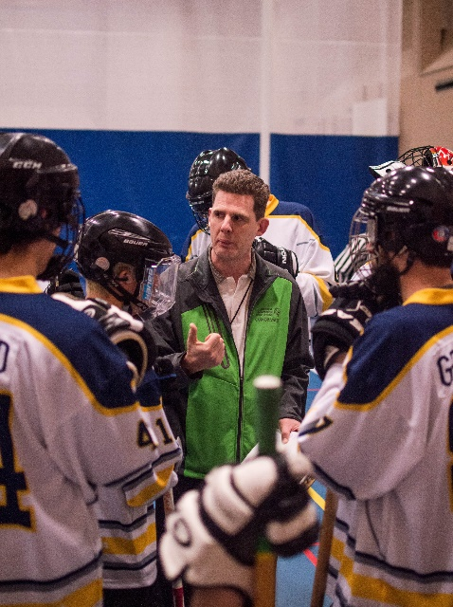
: Click here to enter text.
Name
Years in Special Olympics: Click here to enter text.

Special Olympics Sports: Click here to enter text.

Hobbies outside of Special Olympics:
Click here to enter text.

What do you love the most about Special Olympics?
Click here to enter text.

Greatest accomplishment / memory from your time with Special Olympics:
Click here to enter text.

What are your upcoming goals with Special Olympics?
Click here to enter text.

What would you say to anyone wanting to join Special Olympics, as an athlete, volunteer, or coach?
Click here to enter text.

Anything else we should know about you?
Click here to enter text.
www.specialolympics.bc.ca Toll-free 1.888.854.2276 Email info@specialolympics.bc.ca
Facebook & Instagram @specialolympicsbc Twitter @sobsociety

