RHYTHMIC GYMNASTICS
The Official Special Olympics Sports Rules for Rhythmic Gymnastics shall govern all Special Olympics competitions. As an international sports program, Special Olympics has created these rules based upon Federation Internationale de Gymnastique (FIG) rules for rhythmic gymnastics found at
http://www.fig-gymnastics.com/. FIG or National Governing Body (NGB) rules shall be employed except when they are in conflict with the Official Special Olympics Sports Rules for Rhythmic Gymnastics or Article I. In such cases, the Official Special Olympics Sports Rules for Rhythmic Gymnastics shall apply.

SECTION A – OFFICIAL EVENTS
The following is a list of official events available in Special Olympics.
The range of events is intended to offer competition opportunities for athletes of all abilities. Programs may determine the events offered and, if required, guidelines for the management of those events. Coaches are responsible for providing training and event selection appropriate to each athlete’s skill and interest.
- Level A — Male & Female Athletes
  - Rope
  - Hoop
  - Ball
  - Ribbon
  - All Around
Level A routines are compulsory routines that are performed seated.

- Level B — Male & Female Athletes
  - Rope
  - Ball
  - Clubs
  - Ribbon
  - All Around
Level B routines are compulsory routines that are performed seated.

- Level C — Male & Female Athletes
  - Rope
  - Hoop
  - Ball
  - Ribbon
  - All Around
Level C routines are compulsory routines that are performed standing. These routines are designed for lower level athletes. The emphasis is on developing body skills and apparatus skills separately.
- Level 1 — Female Athletes
  - Rope
  - Hoop
  - Ball
  - Ribbon
  - All Around
Level 1 routines are compulsory routines. At this level, athletes learn to integrate basic apparatus and body skills.
Level 1 Body Skills: Chainé turn, chassé, grand battement, passé balance, skipping steps, straight jump, tiptoe turn

- Level 2 — Female Athletes
  - Rope
  - Hoop
  - Clubs
  - Ribbon
  - All Around
Level 2 routines are compulsory routines. The apparatus and body skills at this level are more complex than in the Level 1 routines.
Level 2 Body Skills: arabesque balance (with leg in front & back), chainé turn, chassé, Hitchkick/scissor jump, passé balance in relevé, passé hops, 180° passé pivot, step hop, tiptoe turn.
- Level 3 — Female Athletes
  - Hoop
  - Ball
  - Clubs
  - Ribbon
  - All Around
Level 3 routines are compulsory routines. At this level, the apparatus and body skills are fully integrated. Athletes must have good technique with the hand apparatus and they must be capable of performing the body skills with good form and control.
Level 3 Body Skills: arabesque balance in relevé (with leg in front & back), arabesque promenade, chainé turn, passé balance in relevé, 180° passé hop, 360° passé pivot, side roll with split, straight jump, vertical jump with leg extended in front
- Level 4 — Female Athletes
  - Rope
  - Ball
  - Clubs
  - Ribbon
  - All Around
Level 4 routines are optional routines. Athletes perform original choreography to music of choice (following FIG guidelines for music). Optional routines should not be dances using the hand apparatus as props. Routines must contain 6 body skills, and show correct rhythmic gymnastics handling skills with the apparatus. The body skills and apparatus handling for Level 4 routines should be more complex than that in the Level 3 routines. Composition requirements for both the body skills and apparatus handling are listed in the Judging section of the Special Olympics Sports Rules for Rhythmic Gymnastics.
- Group Routines – The group routines are compulsory routines designed for teams of athletes, who may be of any level. Group Floor Exercise is divided into two categories: small groups of 4-6 athletes, and large groups of 8-12 athletes. Each group must have an even number of athletes (4, 6, 8, 10, or 12). Group Hoop is for 4 athletes. Refer to the DVD of the 2016-2023 Rhythmic Gymnastics Compulsory Routines for the choreography, floor pattern, and formations of the group routines.
  - Group Rhythmic Floor Exercise
  - Group Hoop

SECTION B – ATTIRE AND EQUIPMENT
- Attire
  - Gymnasts should wear a leotard or unitard, any color. Long tights (down to the ankle) may be worn.
    - Skirted leotards, with the skirt no longer than upper thigh, are acceptable.
    - Leotards may be with or without sleeves, but dance leotards with narrow straps are not

allowed.
    - The cut of the leotard at the top of the legs must not go beyond the fold of the crotch (maximum).
    - Any decoration added to the leotard, either loose or stuck to the garment (flowers, ribbons, etc.) must adhere to the leotard.
    - Leotards must be non-transparent material. Lace or other sheer fabric should be lined in the area of the trunk.
  - Bare feet, gymnastics slippers or rhythmic half-slippers (recommended) are acceptable.
  - Hairstyles should be neat.
  - For the safety of the gymnast, no jewelry is allowed.
- Apparatus
The size of the apparatus can range from child size to senior equipment, based on the gymnast’s size and skill level. Equipment should be color coordinated with the athlete’s leotard. Equipment will be checked prior to competition, as well as during competition, as the gymnast leaves the floor after each routine. If the apparatus does not meet specifications, a deduction of 0.5 will be taken from the score on that event.
  - Rope specifications
    - Material: The rope may be of hemp or synthetic material, provided that it possesses the identical qualities of lightness and suppleness as rope made of hemp.
    - Length: The length should be proportionate to the size of the gymnast.
    - Ends: Handles of any kind are not allowed, but one or two knots are permitted at each end. At the ends (to the exclusion of all other parts of the rope), a maximum of 10 centimeters may be covered by an anti-slip material, either colored or neutral.
    - Shape: The rope may be either of a uniform diameter or be progressively thicker in the center, provided that this thickness is of the same material as the rope.
    - Color: The rope may be any color or combinations of colors.
  - Hoop specifications
    - Material: The hoop may be of wood or plastic, provided that the latter retains its shape during movement. Foreign particles should be removed from inside the hoop before use.
    - Diameter: The interior diameter of the hoop should be from 60-90 centimeters.
    - Weight: A minimum of 150-300 grams and up.
    - Shape: The cross-section of the hoop may be in several different shapes: circular, square, rectangular, oval, etc. The hoop may be smooth or ridged.
    - Color: The hoop may be any color or combination of colors. The hoop may be partially or fully covered with tape to add colors.
  - Ball specifications
    - Material: The ball may be made of rubber or synthetic material (pliable plastic), provided that the latter possesses the same elasticity as rubber.
    - Diameter: 14-20 centimeters.
    - Color: The ball may be of any color.
  - Clubs specifications – Insert Clubs after Ball specifications & before ribbon specifications
    - Material: the clubs may be made of wood or synthetic material.
    - Length: 25-50 centimeters from one end to the other.
    - Shape: A shape similar to that of a bottle. The wider part is called the body. The narrow part, the neck, ends in a small sphere, the head.
    - Color: The clubs may be of a neutral color or may be colored (all or partially) with one or

several colors.

  - Ribbon specifications
    - Stick
      - Material: wood, bamboo, plastic, fiberglass.
      - Diameter: a maximum of 1 centimeter at its widest part.
      - Shape: cylindrical or conical, or a combination of the two shapes.
      - Length: 45-60 centimeters, including the ring, which permits the fastening of the ribbon to the stick. The bottom end of the stick may be covered by an adhesive, anti-slip tape or may have a rubber handle a maximum length of 10 centimeters at the level of the grip. The top of the stick where the ribbon will be attached may consist of:
        - A supple strap (string or nylon) held in place by a nylon thread wound around the stick for a maximum of 5 centimeters.
        - A metal ring fixed directly onto the stick.
        - A metal ring (vertical, horizontal or oblique) fixed to the stick by two metal pins held in place by nylon or metallic thread wound around the stick for a maximum of 5 centimeters.
        - A metal ring (fixed, mobile or pivoting) or a supple strap fixed to a metal tip of no more than 3 centimeters.
        - A metal ring fixed by two metal pins held by a metal tip of 3 centimeters long, which is lengthened by nylon or metallic thread wound around the stick, adding up to a maximum length of 5 centimeters.
        - Color: any choice.
    - Ribbon
      - Material: satin or similar non-starched material.
      - Color: any choice of a single color, two colors or multicolored. c) Width: 4-6 centimeters.
- Length: From one end to the other, the finished length of the ribbon should be a minimum of 1 meter to a maximum of 6 meters (for Levels A, B), a minimum of 2 meters to a maximum of 6 meters (for Level C) and a minimum of 3 meters to a maximum of 6 meters (for Levels 1-4). This part must be in one piece.
  - The end which is attached to the stick is doubled for a maximum length of 1 meter. This is stitched down both sides. At the top, a very thin reinforcement or rows of machine stitching for a maximum of 5 centimeters is authorized.
  - This extremity may end in a strap, or have an eyelet (a small hole, edged with buttonhole stitch or metal circle), to permit attaching the ribbon.
    - Attachment of the ribbon to the stick
      - The ribbon is fixed to the stick by means of a supple attachment, such as thread, nylon cord, or a series of articulated rings.
      - The length of this attachment is a maximum of 7 centimeters (not counting the strap or metal ring at the end of the stick where it will be fastened).
  - Floor
12 meters by 12 meters with a security zone of 1 meter around. A carpeted area may be used or a floor that is neither too tacky nor slippery. The ceiling height does not need to be 8 meters (26’ 3”), but should be fairly high.

SECTION C – SAFETY CONSIDERATION
- Consistent with the Special Olympics philosophy that the movement is athlete-centered, the safety of the athletes is the primary concern when establishing sports rules. The establishment of international guidelines for Special Olympics rhythmic gymnastics compulsory and optional routines will ensure that the athletes follow a proper progression of instructional skills.
- Female athletes who have tested positive for Atlanto-axial subluxation may participate in rhythmic gymnastics. If these athletes elect to do an optional routine, they may not perform pre-acrobatic or acrobatic moves. If they do, the routine is void and the gymnast will be disqualified.

SECTION D – RULES OF COMPETITION
- Only female athletes compete in Levels 1–4. Levels A, B, and C are mixed gender.
- Athletes must compete on the same level in all chosen individual events. (Either A, B, C, 1, 2, 3 or 4.)
- Athletes may specialize by competing in one or more events at their chosen level. Gymnasts who do all four events at a level are considered All-Around. (i.e., Specialist: Level I Hoop and Ball; All-Around: Level I Rope, Hoop, Ball, and Ribbon)
- A gymnast may perform in one or two group routines in addition to individual routines.
- Unified Sports Rhythmic Gymnastics Events
  - All rules and regulations apply equally to athletes and partners.
  - Unified competition is only in the Group events. There must be an equal number of athletes and partners in each group (2 athletes and 2 partners), or a majority of Special Olympics athletes in the group (3 athletes and 1 partner).
- Modifications for Blind Athletes
  - In order to aid the athletes, the following types of assistance are permissible for all levels of competition without deductions:
    - Audible cues, such as clapping, may be used in all routines.
    - Music may be played at any close point outside of the mat, or the coach may carry the music source around the perimeter of the mat.
  - Coaches must notify the meet director and judges of the athlete’s visual impairment before the competition and prior to each event.
- Modifications for Deaf Athletes
  - The athlete may receive a visual aid from the coach to begin her routine as the music starts.
  - Coaches must notify the meet director and judges of the athlete’s hearing impairment before the competition and prior to each routine.
- Modifications for Other Disabilities
  - If special adaptations of equipment are needed, the coach must submit a request with the athlete’s entry and receive permission in writing prior to competition. Coaches should bring the notice of approval to the competition. (See form in the appendix)
  - Coaches must notify the meet director and judges of the equipment modifications prior to each event.
- Level A and B routines have been written for athletes who are unable to stand on their own.
- Level C routines have been written for athletes of lower ability level who can stand on their own.
- The video of the compulsory routines is the official version. If a difference exists between the video and the written text, the video must be followed. For group routines, the video is the only version of the choreography.
- Olympic order for rhythmic gymnastics competition is rope, hoop, ball, clubs, ribbon.

- Awarding of medals
  - Medals (or ribbons) are awarded for each event and for All-Around.
  - Gymnasts may receive a maximum of seven awards: one for each of the four events, one for All Around and two for group
  - Gymnasts who compete Group only may receive a maximum of two awards: one for each group routine

SECTION E – JUDGING
- General Judging Concerns
  - All gymnasts will be required to consider the head judge’s table as side one.
  - At the beginning of each routine, while standing outside the floor exercise boundary, the gymnast must present herself to the head judge. After acknowledging the green flag, the gymnast may take her starting position on the floor. At the end of each event, before leaving the floor, the gymnast must acknowledge the head judge.
  - Prior to the routine and at the end of the routine, judges must acknowledge the self-presentation of the gymnast.
  - For deductions relating to leaving the floor area during a routine, refer to FIG rules.
  - For deductions concerning the apparatus (checking, loss of, replacement, broken, contact with ceiling), refer to FIG rules.
  - For deductions relating to the discipline of coaches and athletes, refer to FIG rules.
  - If an athlete entered in the All-Around receives no score in any one of the events, then she is not eligible for an award in the All-Around event.
- Neutral Deductions – Neutral deductions, which are unique to Special Olympics, are listed below. For all other neutral deductions, refer to FIG rules.
  - Coach communicating to the athlete during a routine. The maximum deduction for assistance that may be taken is 4.0 for a routine. No partial points may be awarded.

Coach assists with the whole routine | - 4.0
Coach assists with the majority of the routine | - 3.0
Coach assists with half the routine | - 2.0
Coach gives slight assistance | - 1.0
  - If coaching assistance is needed, the coach must stand in a designated area in full view of the judges.
  - Out of bounds – The maximum out of bounds deduction, which may be taken for a routine, is 2.0. Apparatus out of bounds - 0.3 each time
Gymnast out of bounds - 0.3 each time

- Judging Forms – The appropriate judging forms for all levels are in the Appendix.
- Judging Level A, B, & C Routines
Levels A, B, & C routines are judged by one panel. If there is more than one judge on the panel, the final score will be the average of all judges’ scores. (Note: If there are four or more judges on the panel, the competition director and/or head judge may elect to drop the high and low scores, and average the middle scores.) Neutral deductions are taken from the final average.
Maximum Value for Routine – 5.0
5 Segments each with a value of 1.0
For each Segment, partial points may be awarded. The following breakdown is a guideline to help determine the amount of credit to be given for each Segment.
1.0 The Segment is performed perfectly, with excellent execution, amplitude, musicality and

apparatus technique.
0.7-0.9 The Segment is performed with minor mistakes in execution, amplitude, musicality and apparatus technique.
0.5-0.6 The Segment is performed with major mistakes in execution, amplitude, musicality and apparatus technique.
0.3-0.4 The Segment is barely recognizable
0.1-0.2 The athlete is on the floor with the correct apparatus.
Note: General impression should be taken into consideration when awarding points for each Segment.
- Judging Compulsory Routines – For Compulsory Routines (Levels 1-3), the judges separate into two panels: D Panel (Difficulty) and E Panel (Execution). To calculate the final score for each gymnast, the score from the D Panel is added to the score from the E Panel. If there is more than one judge on each panel, the average score from the judges on the D Panel is added to the average score from the judges on the E Panel. Neutral deductions are taken from the total.
D Panel (Difficulty) – 10.0
The D Panel will evaluate Identified Skills, Connections, Floor Pattern, and Music. The value for each category is different for Levels 1, 2, and 3. Partial points may be awarded, depending on the, execution and amplitude of the Identified Skills, and the Exactness of Text, including Floor Pattern and Music. Refer to the Judging Sheets in the Appendix for specifics for each level.

Note: If a gymnast drops the apparatus while performing an Identified Skill, the judge must deduct for the drop and possible rhythm breaks, but should not penalize her the full value of the difficulty if the skill is otherwise performed well.

E Panel (Execution) –10.0
8.0 Execution, Amplitude, and Apparatus Technique
2.0 Elegance and General Impression
Execution, Amplitude, and Apparatus Technique (8.0)
The following breakdown is a guideline to help determine the amount of credit to be given for execution and amplitude. The gymnast will begin with a minimum base score of 1.0. The Execution and Amplitude category is divided into sub-categories so that each gymnast will be rewarded for areas in which she excels and not be too harshly penalized for an area in which she may have limitations.
1.0 Minimum base score for being on the floor.
3.0 Form (pointed toes, straight legs, position and extension of the upper body, etc.).
2.0 Amplitude – The general extension and amplitude of both body (height of jumps, extension of the legs and upper body, high on toes, etc.) and apparatus (height of tosses, extension in swings, etc.).
2.0 Apparatus errors (drops, incorrect handling of the apparatus, static apparatus, etc.).
Note: Faults are penalized according to degree:
0.1 Small faults
0.3 Medium faults
0.5 Major faults
Note: Drops of the apparatus are to be penalized as follows:
0.3 Immediate retrieval (without a step)
0.5 Retrieval after 1-2 steps
0.7 Retrieval after 3 or more steps

Elegance and General Impression (2.0)
Elegance includes graceful, soft, flowing arms, supple body movements and an elegant carriage of the body. Good general impression is a performance with few errors. The gymnast must be full of confidence and perform with style and emotion.

- Judging Optional Routines – Level 4 routines should be evaluated by 2 panels: D Panel (Difficulty) and E Panel (Execution). To calculate the final score for each gymnast, the score from the D Panel is added to the score from the E Panel. If there is more than one judge on a panel, the final score for that panel will be the average of all judges’ scores. If a panel consists of 4 or more judges, the head judge may elect to drop the high and low scores and average the middle scores of the judges on the panel. Level 4 routines are evaluated according to the following guidelines:
D Panel: 10.0
3.6 Body Skills
2.4 Apparatus Handling
1.8 Rhythmic Steps
0.2 Virtuosity
2.0 Mastery

- Body Skills– Maximum value of 3.6
  - Required: 6 difficulties (body skills)
  - Required: 2 different leaps/jumps, 2 different pivots, 2 different balances
  - All difficulties must be from the current FIG Code of Points
  - FIG 0.1 difficulties are valued at 0.2
  - FIG 0.2 difficulties are valued at 0.4
  - FIG 0.3 or higher difficulties are valued at 0.6
  - At least one occurrence of Apparatus Handling must be performed in conjunction with each Body Skill
  - Partial points may be awarded, depending on the execution and amplitude of the skill.
    - Full credit is given if the skill is executed to FIG standards of execution & amplitude
    - Partial credit is given, at the judge’s discretion, depending on the execution & amplitude of the skill
    - No credit is given if the skill is omitted or unrecognizable

- Apparatus Handling (2.4)
  - 12 occurrences of apparatus handling are required
  - Apparatus handling is chosen from the current FIG Code of Points (see chart in Appendix)
  - Each handling will be valued at 0.2
  - Each handling may receive credit three times.
  - No partial points may be given.
  - In order to receive credit, the apparatus handling must be performed in conjunction with a Body Skill, Rhythmic Steps, or a body movement as follows:
- 1.2 Body Skills (6)
- 0.6 Rhythmic Steps (3)
- 0.6 Free choice performed with a Body Skill, Rhythmic Steps, or body movement (3)

- Rhythmic Dance Steps – Maximum value of 1.8
  - 3 sequences are required
  - A sequence must have a minimum of 4-6 dance steps that reflect the character of the music & choreography
  - Each sequence is valued at 0.6
  - No credit will be awarded if the Rhythmic Dance Steps are performed with static apparatus.
  - No partial credit may be given

- Virtuosity – Maximum value of 0.2
  - At the judge’s discretion, the athlete may be awarded up to 0.2 points for virtuosity.
  - No partial points may be given.
  - To receive points for virtuosity, the athlete must show:
    - Clean execution and excellent amplitude throughout the entire routine
    - A clear connection between the choreography & the music
    - Intricate apparatus handling
    - Complex dance steps that reflect the character of the music

- Mastery – Maximum value of 2.0
  - There is no requirement for Mastery elements

  - Mastery elements are chosen from the current FIG Code of Points (see chart in Appendix)
  - Each Mastery element is valued at 0.4
  - A maximum of 5 mastery elements may receive credit
  - No partial points may be given.

E Panel: 10.0
Partial points may be awarded, as listed below.
7.0 Execution, Amplitude, and Apparatus Technique
1.0 Connections
1.0 Musicality
0.5 Floor pattern and use of space
0.5 Elegance and Expression

Execution, Amplitude, and Apparatus Technique (7.00)
The following breakdown is a guideline to help determine the amount of credit to be given for execution and amplitude. The gymnast will begin with a minimum base score of 1.0. The Execution and Amplitude category is divided into sub-categories so that each gymnast will be rewarded for areas in which she excels and not be too harshly penalized for an area in which she may have limitations.
3.0 Form (pointed toes, straight legs, position and extension of the upper body, etc.).
2.0 Amplitude – The general extension and amplitude of both body (height of jumps, extension of the legs and upper body, high on toes, etc.) and apparatus (height of tosses, extension in swings, etc.).
2.0 Apparatus errors (drops, incorrect handling of the apparatus, static apparatus, etc.).
Note: Faults are penalized according to degree:
0.1 Small faults
0.3 Medium faults
0.5 Major faults
Note: Drops of the apparatus are to be penalized as follows:
0.3 Immediate retrieval (without a step)
0.5 Retrieval after 1-2 steps
0.7 Retrieval after 3 or more steps

Connections (1.0)
The composition should be developed by the technical, aesthetic, and connecting elements, where one movement passes smoothly into the next, including contrasts in the speed/intensity
(dynamism), amplitude and levels of the movements, performed in relationship with the music. (FIG)

Musicality (1.0)
The character of the music should define the guiding idea/theme of the composition, and the gymnast must convey this guiding idea to the audience from the beginning to the end of the exercise. (FIG)

Floor Pattern and Use of Space (0.5)
The floor area must be used completely:
- Different levels (gymnast in flight, standing, on the floor, etc.)
- Variety of directions/trajectories of body/apparatus movements (forward, backwards, etc.)
- Variety in the modalities of travelling (FIG)

Elegance and Expression (0.5)
Elegance includes graceful, soft, flowing arms, supple body movements and an elegant carriage of the body. Expression through the use of body and facial expression, the gymnast must convey the idea of the choreography to the audience. The gymnast must be full of confidence and perform with style and emotion.

APPARATUS HANDLING ROPE 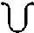
- Passing through the rope with a jump/leap. Rope turning forward, backward, or to the side
- Passing through the rope with series (3 minimum) of small hops. Rope turning forward, backward, or to the side
- ‘’Echappe’’
- Spirals (double or more rotations of the rope’s end during ‘’echappe’’)
- Figure eight or ‘’sail’’ movement with ample movement of the trunk (Rope held in two hands)
- Large circles (rope held in two hands)
- Catch of the rope with one end in each hand
- Series (3 minimum) of rotations. Rope folded in two
- One free rotation around a part of the body
- One rotation of the open, stretched rope, helded by the middle or by the end
- Small or medium throw and catch
- Wrapping or swings

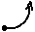

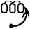

BALL

- Free roll of the ball on the body
- Large ( 1 meter minimum) roll of the ball on the floor
- Series (3 minimum) of small rolls of the ball on the floor
- Bounces
  - Series (3 min.) of small bounces (below knee level)
  - One high bounce (knee level and higher)
  - Visible rebound from a part of the body
- Balancing of the ball – For example: Swings or Figure eight of the ball with circle movements of the arms (circumduction)
- Catch of the ball with one hand
- ’’Flip over’’ movement of the ball
- Rotations of the hand(s) around the ball
- Series (3 min.) of assisted small rolls
- Roll of the body over the ball on the floor
- Thrust/push of the ball from different parts of the body
- Small or medium throw and catch

CLUBS

 | - Mills- at least 4 small circles of the clubs with time delay and by alternating crossed and uncrossed wrists/hands each time
 | - Series (3 minimum) of small circles with both clubs
 | - Asymmetric movements of 2 clubs, must be different in their shape or amplitude and in the work planes or direction
 | - Small throws and catches with rotation of 2 clubs together, simultaneously or alternating
- Free rotations of 1 or 2 clubs on the part of the body or on the floor
- Rolls of 1 or 2 clubs on the part of the body or on the floor
- Rebound of 1 or 2 clubs from the body
- Swings
- ‘’Sliding’’
- Tapping (1 minimum)
- Thrust/push of the clubs from different part of the body
 | - Series (3 minimum) of small circles with 1 club
 | - Small or medium throw and catch of 1 club
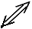 | - Throw or catch of 2 clubs, simultaneous
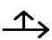 | - Throw or catch of 2 clubs, asymmetric
 | - ‘’Cascade’’ throws (double or triple)

RIBBON

 | - Spirals (4-5 waves), tight and same height
 | - Spirals on the floor
 | - Snakes (4-5 waves), tight and same height
 | - Snakes on the floor
 | - Passing through or over the pattern of the ribbon
 | - ‘’Echappe’’
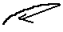 | - Boomerang in the air or on the floor
- Rotational movement of the ribbon stick around the hand
- Roll of the ribbon stick on the part of the body
- Rebound of the stick from the part of the body
- Wrapping
- Figure eights, swings, large circles
- Movement of the ribbon around the part of the body created, when the stick is held by different parts of the body (hand, neck ,knee, elbow) during body movements or difficulties with rotation (not during ‘’slow turn’’)
 | - Small or medium throw and catch

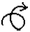MASTERY

1. | 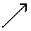 or | Throw or catch in combination with the following criteria:
 |  | Jump or leap
 |  | Rotation element
 |  | Under the leg
 |  | Passing through (for rope and for hoop)
 |  | Outside of visual control during the throw/catch
 |  | Without the help of the hands during the throw/catch
 |  | Direct catch in a roll
 |  | Direct re-throw/ re-bound
 |  | Direct catch in rotation (hoop)
 |  | Catch the ball with one hand
 |  | Catch on the floor without help of the hands
2. |  | Rotation element + apparatus handling
 | Examples: | (for rope and for hoop) or (for ball), or (for clubs) or for ribbon or
3. | Combinations | Handling with 2 different criteria to get credit
 | Examples: | ( )

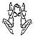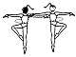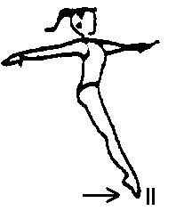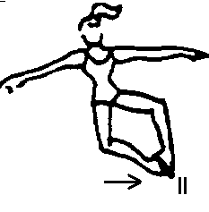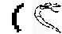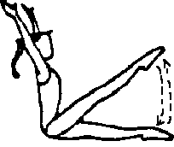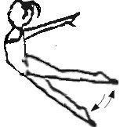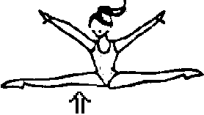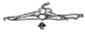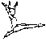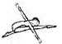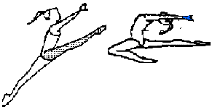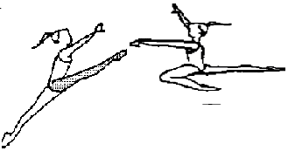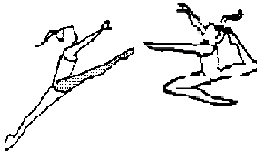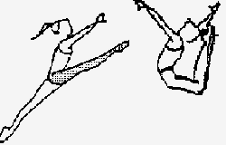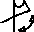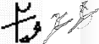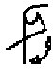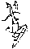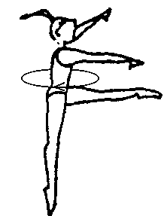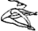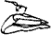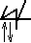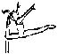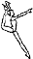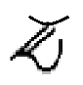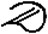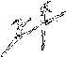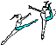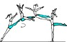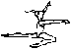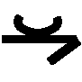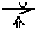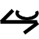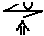SYMBOLS OF JUMPS/LEAPS

Special Olympics 0.2 | Special Olympics 0.4 | Special Olympics 0.6 | Special Olympics 0.6 | Special Olympics 0.6 | Special Olympics 0.6 | Special Olympics 0.6
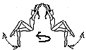

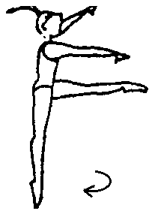

 |  | 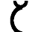
 | 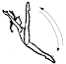 | 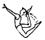
 |  | 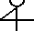 | 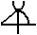
 | 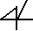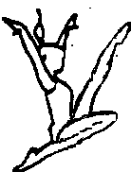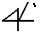 |  | 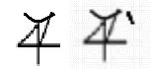 | 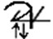
 |  | 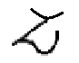 | 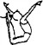
 |  |  | 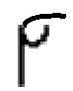
 |  |  | 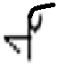 | 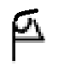
 |  |  |  | 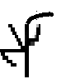
 |  |  |  |  |  | 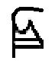
 |  | 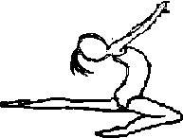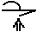
 |  |  |  | 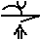 | 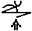

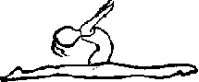

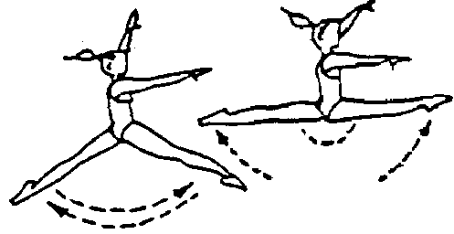

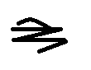

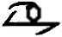

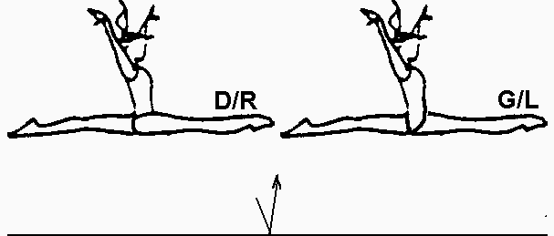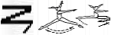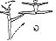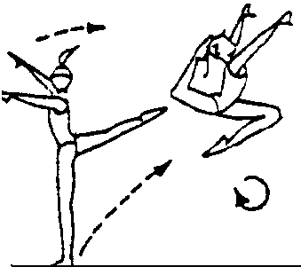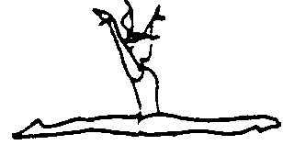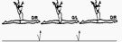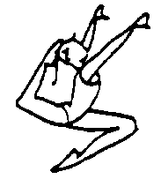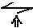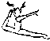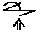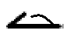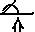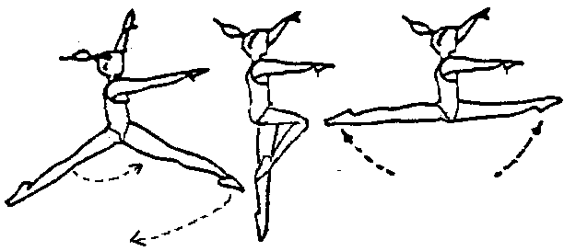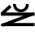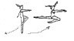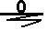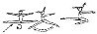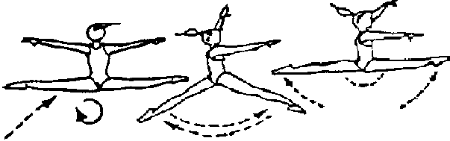

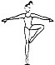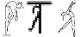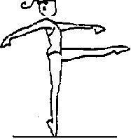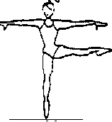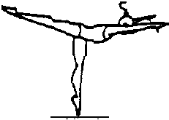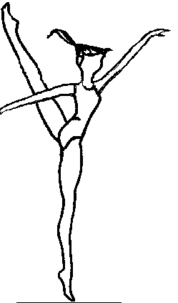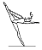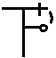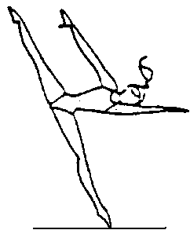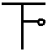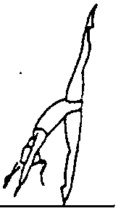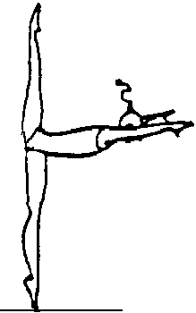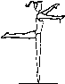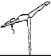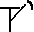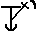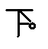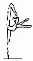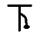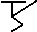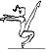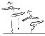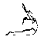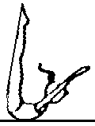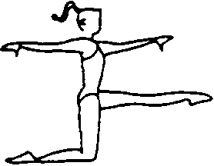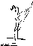SYMBOLS OF BALANCES

Special Olympics 0.2 | Special Olympics 0.4 | Special Olympics 0.6 | Special Olympics 0.6 | Special Olympics 0.6 | Special Olympics 0.6 | Special Olympics 0.6
 |  |  | 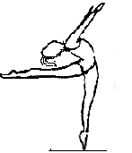
 |  |  | 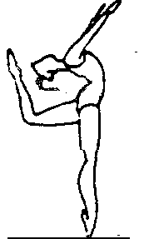
 |  |  |  | 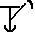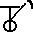
 |  |  | 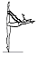
 |  |  |  | 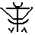
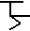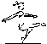

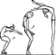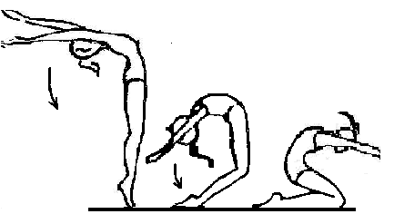

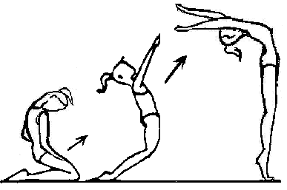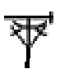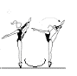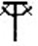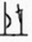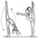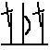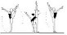

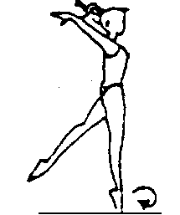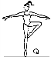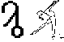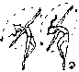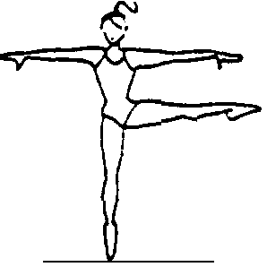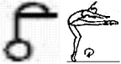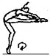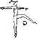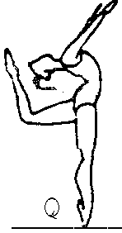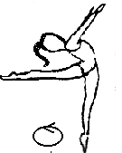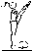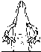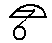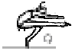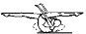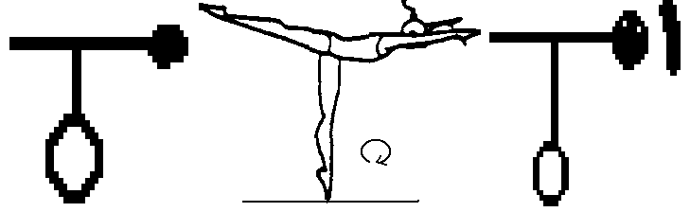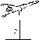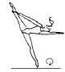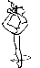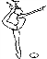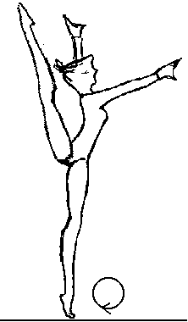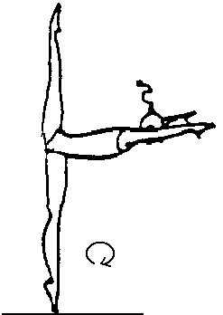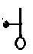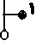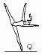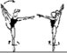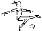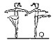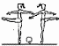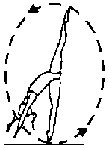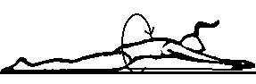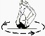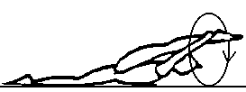SYMBOLS OF PIVOTS

Special Olympics 0.2 | Special Olympics 0.4 | Special Olympics 0.6 | Special Olympics 0.6 | Special Olympics 0.6
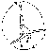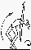 |  |  | 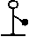

- Judging Group Routines:
For Group Routines, the judges separate into two panels: D Panel (Difficulty) and E Panel (Execution). To calculate the final score for each group, the score from the D Panel judge is added to the score from the E Panel judge. If there is more than one judge on each panel, the average score from the judges on the D Panel is added to the average score from the judges on the E Panel. Neutral deductions are taken from the total.
Neutral Deductions – Neutral deductions are the same for Group as they are for individual competition, with one addition: non-conforming leotard or apparatus. All gymnasts in a group must wear matching leotards, identical in shape and color. All gymnasts must use apparatus identical in weight, shape, and size: only the color can differ. The deductions for non-conforming leotards or apparatus are as follows:
0.1 Each leotard that does not match (maximum deduction is 0.3 for groups of 4-6, and 0.7 for large floor exercise groups of 8-12)
0.1 Each apparatus that does not match (maximum deduction is 0.3)

Group Floor Exercise
Group Floor Exercise is divided into two categories: small groups of 4-6 athletes, and large groups of 8-12 athletes. Each gymnast in the group has a partner. The pairs may be spaced at the coach’s discretion in any formation on the floor. Refer to the DVD of the 2016-2023 Rhythmic Gymnastics Compulsory Routines for the choreography

D Panel (Difficulty and Exactness of Text) – 10.0
6.0 Identified Skills
2.0 Connections
1.0 Uniformity of the group
1.0 Music

Identified Skills (6.0 – 6 skills, each with value of 1.0)
For each Identified Skill, partial points may be awarded. Refer to the Judging Form in the Appendix for the list of Identified Skills. The following breakdown is a guideline to help determine the amount of credit to be given for each of the Identified Skills in groups of either small or large.
1.0 Body skill is executed flawlessly by all gymnasts.

0.9-0.1 Awarded at judge’s discretion, considering the execution of the skill and number of gymnasts.

0.0 Body skill is omitted or unrecognizable.

Connections (2.0)
This category is to rate the group on the correctness of the routine other than the Identified Skills. In order to evaluate the connections accurately, judges must be completely familiar with the routine. The following breakdown is a guideline to help determine the amount of credit to be given for Connections.
2.0 The routine is executed as written, with smooth connections between body skills, and fluidity in movements where gymnasts work together.
1.0-1.9 The routine is basically correct, with minor mistakes in the connections.
0.6-0.9 The routine is somewhat correct, with major mistakes in the connections.
0.5 The group is on the floor.

Uniformity of the Group – All gymnasts performing with precision (1.0)
The following breakdown is a guideline to help determine the amount of credit to be given for the Uniformity of the Group.
1.0 All gymnasts working together with synchronization.
1.0-1.9 Minor mistakes in synchronization.
0.6-0.9 Major mistakes in synchronization.

0.5 Gymnasts are working independently.
Music (1.0)
The following breakdown is a guideline to help determine the amount of credit to be given for interpretation and synchronization with the music.
1.0 The routine perfectly matches the music. 1.0-1.9 The routine basically matches the music. 0.6-0.9 The routine somewhat matches the music.
0.5 The routine has no connection with the music.
E Panel (Execution) – 10.0
8.0 Execution and Amplitude
2.0 Elegance and General Impression
For specifics, refer to the judging guidelines for individual routines.

Group Hoop
The Group Hoop routine is designed for groups of four gymnasts. Refer to the DVD of the 2016-2023 Rhythmic Gymnastics Compulsory Routines for the choreography

D Panel (Difficulty and Exactness of Text) – 10.0
6.0 Difficulty
2.0 Connections
1.0 Uniformity of the group
1.0 Music
Difficulty (6.0) – 2 Identified Skills, 2 Exchanges and 2 Formations, each with a value of 1.0
Refer to the Judging Form in the Appendix for the list of Identified Skills, Exchanges, and Formations.
For each Identified Skill, partial points may be awarded. The following breakdown is a guideline to help determine the amount of credit to be given for each of the Identified Skills.
1.0 Body skill is executed flawlessly by all gymnasts.
0.8 Body skill is executed well by at least 3 gymnasts.
0.6 Body skill is executed with minor mistakes by 2 gymnasts.
0.4 Body skill is executed with major mistakes.
0.2 Body skill is executed, but barely recognizable.
0.0 Body skill is omitted or unrecognizable.
The following breakdown is a guideline to help determine the amount of credit given for each Exchange.
1.0 Exchange is completed by all gymnasts.
0.8 1 gymnast drops the apparatus.
0.6 2 gymnasts drop the apparatus.
0.4 3 gymnasts drop the apparatus.
0.2 4 gymnasts drop the apparatus.
0.0 No attempt is made to exchange.
The following breakdown is a guideline to help determine the amount of credit given for each Formation.
1.0 All gymnasts are in the exact formation.
0.8 1 gymnast is out of formation.

0.6 2 gymnasts are out of formation.
0.4 3 gymnasts are out of formation
0.2 Formation is barely recognizable.
0.0 Formation is unrecognizable.
Connections (2.0)
This category is to rate the group on the correctness of the routine other than the Identified Skills. In order to evaluate the connections accurately, judges must be completely familiar with the routine. The following breakdown is a guideline to help determine the amount of credit to be given for Connections.
2.0 The routine is executed as written. With smooth connections between body skills, technically correct connections in apparatus handling and a flowing connection between the body skills and apparatus handling.
1.0-1.9 The routine is basically correct, with minor mistakes in the connections. 0.3-0.9 The routine is somewhat correct, with major mistakes in the connections. 0.1-0.2 The group is on the floor with the correct apparatus.
Uniformity of the Group – All gymnasts performing with precision (1.0)
The following breakdown is a guideline to help determine the amount of credit to be given for the Uniformity of the Group.

1.0 All gymnasts working together with synchronization.
1.0-1.9 Minor mistakes in synchronization.
0.6-0.9 Major mistakes in synchronization.
0.5 Gymnasts are working independently.

Music (1.0)
The following breakdown is a guideline to help determine the amount of credit to be given for interpretation and synchronization with the music.
1.0 The routine perfectly matches the music. 1.0-1.9 The routine basically matches the music. 0.6-0.9 The routine somewhat matches the music.
0.5 The routine has no connection with the music.
E Panel (Execution) – 10.0
8.0 Execution and Amplitude
2.0 Elegance and General Impression

For specifics, refer to the judging guidelines for individual routines.

APPENDIX
RHYTHMIC GYMNASTICS ROUTINES & JUDGES FORMS

Level A Rope

The video is the official version of the routine. This written text is merely an additional teaching tool. Some skills, such as complex dance steps or movements of the free arm, are not described in the written text and should follow the video.

Music: We Speak No Americano

Starting position: Sitting. Hold the ends of the rope. Rope is extended on the horizontal plane, touching the legs.

Counts

1-4 Hold

5-8 Bending the arms in toward the body, raise the rope overhead.

1-8 Twist the rope: Raise the right hand and lower the left hand to hold the rope on the vertical plane. Move the hands to hold the rope on the horizontal plane. Then, raise the left hand and lower the right hand to hold the rope on the vertical plane. Move the hands to hold the rope on the horizontal plane.

1-8 Repeat (Twist the rope)

1-8 Bending and extending the arms, circle the rope to the right two times.

1-8 Holding the rope in a U-shape swing right-left-right-left.

1-2 Close the hands together. Separate the hands to extend the rope on the horizontal plane. 3-4 Pause
1-4 Spin the rope forward. Separate the hands to extend the rope on the horizontal plane.

5-8 Touch the right hand to the right shoulder. Extend the arms forward to hold the rope on the horizontal plane.
1-4 Repeat spin.

5-8 Touch the left hand to the left shoulder. Extend the arms forward to hold the rope on the horizontal plane.

1-4 Repeat the previous 16 counts

End Raise the rope overhead for the ending pose.

Music: Hawaii Five-O

Starting position: Sitting. Hold the hoop with two hands (outside grip) on the horizontal plane, at shoulder level.

Counts

1-8 Shake the hoop.

1-4 Raise the hoop overhead on the horizontal plane.

Lower to the starting position.

5-8 Raise the hoop overhead on the horizontal plane.

Lower the hoop in front on the frontal plane.

1-8 On the frontal plane, rotate the hoop four times (left-right-left-right).

1-4 Hold the hoop on the frontal plane. Touch the right hand to the right shoulder, and extend the left arm forward, moving the hoop to the vertical plane.
Extend the arms to return the hoop to the frontal plane.

5-8 Repeat, touching the left hand to the left shoulder.

1-4 Place the lower edge of the hoop on the legs. Slide the hands down one at a time to grasp the hoop with the hands close together.

5-8 Tap the hoop on the floor two times to the right and two times to the left.

1-end Bending and extending the arms, circle the hoop to the right on the horizontal plane two times.

Raise the hoop overhead to the ending pose.

Music: Safety Dance

Starting position: Sitting. Hold the ball with two hands, resting on the legs.

Counts

1-4 Hold.

5-8 Roll the ball out the legs and in.

1-4 Extend the arms to raise the ball overhead. Bend the arms to hold the ball at the chest. 5-8 Extend the arms forward. Bend the arms to hold the ball at the chest.
1-8 Roll the ball out the arms.

Roll the ball in the arms. Bend the elbows to trap the ball (forearms parallel).

1-4 Roll the ball out the arms.

5-8 Toss and catch with two hands.

1-8 Bend the arms to hold the ball at the chest. Shake the ball. Extend the arms forward. 1-8 Touch the ball to the right shoulder. Extend the arms forward.
Touch the ball to the left shoulder. Extend the arms forward.

Bending and extending the arms, circle the ball to the left two times. Continue the circle to place the ball on the legs. Extend the left arm to the ending pose..

Music: Finding Neverland

Starting position: Sitting. Extend the right arm to the side.

Counts

1-8 Horizontal snake

1-8 Four overhead swings (left-right-left-right)

1-4 Spirals

5-8 Two overhead circles to the left

1-6 Swing the ribbon up. Horizontal snakes down in front of the body. 1-6 Repeat
1-6 Repeat

1-end Three horizontal swings in front of the body (left-right-left). Grasp the stick near the ribbon connection. Move the arms up to the ending pose.

Music: Chicago Shake

Starting position: Sitting. With arms bent, hold the doubled rope (both knots in the right hand) on the horizontal plane.

Counts

Intro Hold

1-8 Extend the arms to the right, and circle the rope to the left.

Tilt the head right-left.

1-8 Repeat

1-8 Spin the rope forward. Extend the rope.

Twist the rope, raising the left arm and lowering the right arm to hold the rope on the vertical plane. Raise the right arm and lower the left arm to hold the rope on the vertical plane.

1-8 Repeat

1-8 Release the looped end of the rope. Figure 8s (left-right-left). Swing the rope on the right side of the body.

1-8 Overhead rotations to the left.

Lower the right arm and grasp the rope with the left hand (in an overgrip), near the right hand. Slide the left hand to hold near the looped end of the rope. Raise arms overhead to the ending pose.

Music: Another One Bites The Dust

Starting position: Sitting. Hold the ball with two hands on the right hip.

Counts

1-4 Hold

5-8 Touch the ball to the right hip, then the left hip.

1-8 Holding the ball with two hands, counter-clockwise frontal circle.

1-8 With arms extended in front, twist the ball four times (left hand on top–right-left-right).

1-4 Roll the ball in the arms, bending the elbows to trap the ball by the chest (forearms parallel). 5-8 Roll the ball out the arms and catch with two hands.
1-4 Touch the ball to the right shoulder. Extend the arms forward. 5-8 Touch the ball to the left shoulder. Extend the arms forward.
1-4 Toss the ball with two hands. Keeping the elbows lifted and the arms parallel, bend the elbows to trap the ball in the arms by the chest.

5-8 Extend the arms to roll the ball out and catch with two hands.

1-16 Repeat the previous 16 counts. Raise the ball overhead to the ending pose.

Music: Boogie Shoes

Starting position: Sitting. With arms extended to the front, hold the neck of the clubs with one club in each hand. The clubs are parallel, on the vertical plane.

Counts

1-8 Shake the clubs.
1-8 Bend the elbows and extend the arms to the right. Circle the clubs to the left two times. 1-4 Place the head of the clubs on the legs and slide the hands down to grasp the clubs by the
head.

1-12 Roll the clubs forward.

1-4 Extend the arms forward,

5-8 Open the arms to the sides. Swing the arms to the front. 1-4 Tap the clubs. Raise the arms overhead.
5-8 Lower the right arm to the side.

1-4 At the same time, raise the right arm overhead and lower the left arm to the side. 5-8 Raise the left arm overhead.
Lower the arms in front of the body. Place the body of the clubs on the legs. Extend the arms and push the head of the clubs forward for the ending pose.

Music: Say Hey

Starting position: Sitting. Extend the right arm to the side.

Counts

1-8 Spirals on the side

1-4 Swing the ribbon up. Horizontal snakes down in front of the body.

1-4 Repeat.

1-8 Holding the ribbon stick with both hands, swing the ribbon over the shoulders 4 times (right- left-right-left)

1-8 Four overhead circles to the left

1-end Four overhead swings (left-right-left-right). Counterclockwise circle to the ending pose

Music: Chicago Shake

Starting position: Facing Side 1, stand on the center of the rope with feet together. With one knot in each hand, hold the rope by the shoulders with elbows extended to the sides.

Counts

Intro Hold

1-8 Extend the arms to the right, and circle the rope to the left. Return to the starting position.

Twist hips.
1-4 Extend the arms to the right, and circle the rope to the left. Return to the starting position. 5-8 Lifting the knees, step backwards (left-right) off the rope, extending the arms to hold the
rope in a U-shape.

1-8 Swing the rope in a U-shape (right-left-right-left)

1-6 Put both knots in the right hand. Grasp the rope with the left hand (in an overgrip), near the right hand. Slide the left hand to hold near the looped end of the rope, (on the horizontal plane).

7-8 Straight jump, raising the arms overhead.

1-6 Tiptoe turn to the right, holding the arms overhead.

7-8 Lower the arms in front of the body to quadruple the rope, holding the knots and looped end of the rope in the right hand.
1-8 Counter-clockwise rotations on the frontal plane. Extend the right leg to the side for the ending pose.

Music: Boogie Shoes

Starting position: Facing Side 1, stand with feet together. Hold the hoop in an overgrip, on the frontal plane, with the bottom edge of the hoop on the floor.

Counts

1-8 Assisted spin (using two hands) to the right on the vertical axis. Catch the hoop with two hands in an undergrip.
1-8 Walk forward four steps in relevé (right-left-right-left), raising the hoop overhead.

1-4 Tiptoe turn to the right.

1-4 Holding the hoop overhead, plié and bend the torso sideways to the right.

5-8 Holding the hoop overhead, plié and bend the torso sideways to the left.

1-4 Holding the hoop overhead, plié and bend the torso sideways to the right.

5-8 Lower the hoop in front of the body.

1-2 Swinging the hoop overhead, straight jump.

3-4 Lower the hoop in front of the body.
1-4 Step sideways to the right, extending the left leg to the side. Swing the hoop to the right. 5-8 Plié to shift the weight left, extending the right leg to the side. Swing the hoop to the left. 1-4 Plié to shift the weight right, extending the left leg to the side. Swing the hoop to the right. 5-8 With the right hand, lower the hoop to the floor and extend the left arm on a high side
diagonal to the ending pose.

Music: Another One Bites The Dust

Starting position: Facing Side 1, stand on the right foot with the left knee bent and the left foot on toes by the right foot. With two hands, hold the ball on the right hip.

Counts

1-8 Shake hips

1-8 Lower the right heel to stand on two feet. Holding the ball with two hands, counter- clockwise frontal circle.
1-8 Raising the ball overhead, tiptoe turn to the right. Lower the arms to hold the ball in front of the body.

1-4 Roll the ball in the arms, bending the elbows to trap the ball by the chest (forearms parallel). 5-8 Roll the ball out the arms and catch with two hands.
1-4 While bending the knees, bend the elbows and touch the ball to the right shoulder. While straightening the knees, extend the arms forward.
5-8 Repeat, touching the ball to the left shoulder.

1-4 With two hands, bounce and catch the ball.
5-8 Straight jump. Swing the ball overhead on the jump and lower in front on the landing. 1-8 Holding the ball in front of the body, four marching steps (stepping on the left foot and
raising the right knee first).

1-4 Close feet together in plié. Toss and catch the ball with two hands.

5-8 Bend the arms, elbows to the sides, and hold the ball against the chest. Extend the right leg to the side (toes lifted) to the ending pose.

Music: Say Hey

Starting position: In the middle of the floor, facing Side 1, stand with feet together. Left hand on the hip. Right arm extended forward.

Counts

1-4 Spirals

5-8 Two knee bends with spirals

1-4 Swing the ribbon up. Horizontal snakes down in front of the body.

5-8 Straight jump, swinging the ribbon up. Horizontal snakes down in front of the body.

1-8 Holding the ribbon stick with both hands, four knee bends, swinging the ribbon over the shoulders (right-left-right-left)
1-4 Overhead circle to the left. Plié, swinging the ribbon to the left, in front of the body. 5-8 Tiptoe turn to the right with arms extended to the sides.
1-end Five steps forward in relevé (left-right-left-right-left) with overhead swings.

Lunge right, with a large counter-clockwise frontal circle. Swing ribbon to the right to the ending pose.

Music: Hoedown Throwdown

Starting position: In Corner 6, facing Side 1, stand with feet together. Hold the doubled rope on the horizontal plane in front of the body (knots in the right hand).

Counts

1-4 Rhythmic steps (counts 1-16): Bend the right knee, lifting the right heel. Close the arms together, bringing the rope to a U-shape. Straighten the knee, lowering the heel. Open the arms to the stretch the rope.

5-8 Repeat, bending the left knee.

9-16 Travelling to the right, bending and straightening the knees, twist the feet (heels-toes-heels- toes). Spin the rope forward.

1-4 Stretching the rope, plié. Bend forward to trap the rope against the waist. Return to an upright position and relevé. Raise the rope overhead.
5-8 Chainé turn to the right. Step right and close feet together.

1-4 Step sideways to the right and extend the left leg to the side. Release the rope with the left hand and swing the rope to the right. Grasp one knot in each hand.

5-8 With a plié, shift the weight to the left. Swing the rope to the left in a U-shape.

Step right and swing the rope to the right in a U-shape. Turning to face Side 3, close feet together in relevé. Continue to swing the rope overhead in a U-shape.

1-4 Lower the heels as the rope swings behind the body.

5-8 Plié and cross the arms in front of the body (elbows slightly bent). Straighten the legs and open the arms.
1-4 Passé balance (right knee is lifted in a parallel passé position). Close feet together.

5-8 Two steps backwards (right-left). Swing the rope forward and overhead in a U-shape.
Extend the right leg forward and lift the toes to trap the rope under the right foot.

1-4 Turning to face Corner 2, close the right foot to the left foot. With the right hand, grasp the middle of the rope to make a short loop on the right side of the body. Begin backward rotations.

1-8 Step right and close feet together. Swing the rope forward, releasing the middle of the rope to grasp one knot in each hand.
Cross the right foot over the left foot (left hand on hip). Relevé and turn to face Corner 8. Begin overhead rotations. Lower the heels.

1-8 Travelling toward Corner 8, two steps forward in relevé (right-left) with overhead rotations.
Close feet together.

Plié. Lower the right arm to allow the rope to wrap around the legs. Straighten the knees and move the arms to the front and grasp one knot in each hand.
1-4 Cross the hands to wrap the rope around the arms

  - Plié. Straight jump, swinging the arms overhead. Step sideways on the left foot and lift the toes of the right foot in the ending pose.

IDENTIFIED SKILLS

    - Rhythmic steps
    - Chainé turn
    - Swings
    - Passé balance
    - Overhead rotations
    - Straight jump

Level 1 Hoop

The video is the official version of the routine. This written text is merely an additional teaching tool. Some skills, such as complex dance steps or movements of the free arm, are not described in the written text and should follow the video.

Music: Lewis Boogie

Starting position: Near Corner 6, facing Side 1, stand on the left foot with the right leg extended to the side. In an undergrip, hold the hoop to the left on the frontal plane.

Counts

1-4 Plié to shift the weight to the right. Swing the hoop to the right on the frontal plane.

Repeat to the left.

5-8 Side chassé to the right, circling the hoop on the frontal plane in a clockwise direction, changing hands overhead. Finish standing on the right foot with the left leg extended to the side. Hold the hoop to the right on a high diagonal.

1-4 Plié on the right leg (side lunge) and tap the hoop on the floor to the right. Small jump to change to a left side lunge. Tap the hoop on the floor to the left.

5-8 Tiptoe turn to the right. Hold the hoop on the vertical plane in front of the body (right hand high, left hand low).
1-4 Moving the hoop to the frontal plane with the left hand high, travel to the right, twisting the feet (alternating heels and toes) with pliés. Twist the hoop on the frontal plane.

5-8 Pose, bending the arms and leaning the torso to look forward through the center of the hoop.

1-12 Holding the hoop in the right hand, lower to the floor on the right side of the body. Assisted hoop spin (with the right hand) to the right. Walk around the hoop in relevé. Close feet together, facing Side 1.

Assisted roll (right to left) while stepping left in plié to shift the weight to the left.

Holding the hoop with the left hand on the frontal plane, and the right arm extended overhead, passé balance (right knee lifted in a turned out position).

1-8 Close feet together. In an undergrip, hold the hoop with two hands in front of the body.
Through the turning hoop, two small jumps (right-left).

On the second jump, finish inside the hoop, with the hands in an outside grip. Bending and straightening the knees, twist.

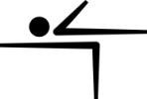 GYMNASTICS – RHYTHMIC

1-4

right, raising the hoop overhead. Touch the left foot by the right foot.

Chainé turn

5-8 Chainé turn left, lowering the hoop. Touch the right foot by the left foot.

- end Travelling toward Side 1, two forward chassés right, flutter the hoop. Step forward on the right foot. Kneel behind on the left knee. Place the right knee on the floor (knees hip distance apart). Release the hoop. Sit on the hoop to flip the hoop backwards over the head (use arms to assist).

Raise the hips, extending the right arm forward and the left arm high in the ending pose.

IDENTIFIED SKILLS

  - Side chassé
  - Tiptoe turn
  - Hoop spin
  - Assisted roll to passé balance
  - Chainé turns
  - Forward chassés

Level 1 Ball

The video is the official version of the routine. This written text is merely an additional teaching tool. Some skills, such as complex dance steps or movements of the free arm, are not described in the written text and should follow the video.

Music: One World

Starting position: In Corner 6, facing Side 7, stand in plié with the feet together. Bend forward to hold the ball with the palms of the hands against the legs.

Counts

1-8 Three times, plié deeper, rolling the ball slightly down the legs, and return to the starting position, rolling the ball up the legs. Straighten the knees and extend the arms to hold the ball with two hands in front of the body.

1-8 Holding the ball in the right hand, sagittal swing on the right side of the body, bending and straightening the knees.

Holding with two hands, place the ball on the right hip.

Turning to face Side 1, step right and point the left foot to the side. Shake hips two times.

1-4 Close the left foot to the right foot in plié. Bend the arms to bring the ball to the chest.
Relevé and extend the arms to hold the ball overhead.

5-8 Tiptoe turn to the right. Bend the arms and bring the ball to the chest. 1-4 Shake hips. Bending and extending the arms, circle the ball to the left.
1-4 Step forward left in plié, holding the ball near the chest. Straighten the left leg and point the toes of the right foot by the left foot, extending the arms forward.

5-8 Repeat, stepping on the right foot.

Close feet together and lower the ball in front of the body.

1-8 Roll the ball up the body and raise overhead. Passé balance (right leg lifted in a turned out position).

Close feet together and turn to face Corner 2. Lower the ball in front.

1-4 Plié and swing the ball down. Straighten the legs. Toss and catch with two hands.

5-8 Bend the knees and touch the ball to the right hip or shoulder (The front & back views of the video are different, so either is correct).. Straighten the legs and extend the arms to hold the ball in front.

Repeat, touching the ball to the left hip or shoulder.

1-4 Bounce and catch with two hands.

1-10 In relevé, walk forward seven steps (starting with the left foot) toward Corner 2, rolling the ball up the body and out the arms.
Raising the ball overhead, kick the right leg forward in grand battement.

Step forward right. Close feet together. Lower the ball to the front.

1-4 Turning to face Side 1, plié. Bend the arms to bring the ball to the chest. Straighten the legs and tendu the right foot to the side, extending the arms on a high left diagonal.

1-8 Two side chassés to the right with two large counter-clockwise frontal circles.

Facing Corner 2, finish standing on the right foot with the left leg extended.

- end Bend the arms to bring the ball to the chest. Extend the right arm to the ending pose.

IDENTIFIED SKILLS

  - Tiptoe turn
  - Passé balance
  - Toss and catch with two hands
  - Bounce and catch with two hands
  - Grand battement
  - Side chassés

Level 1 Ribbon

The video is the official version of the routine. This written text is merely an additional teaching tool. Some skills, such as complex dance steps or movements of the free arm, are not described in the written text and should follow the video.

Music: Crystallize

Starting position: In Corner 6, facing Side 1, stand with feet together, arms extended to the sides, holding the ribbon stick in the right hand and the end of the ribbon in the left hand.

Counts

1-4 Walk forward four steps in relevé (left-right-left-right), with figure-8s.

1-8 Close the feet together, releasing the end of the ribbon. Crossing the right arm in front of the body, swing the ribbon to the left and begin spirals.

Tiptoe turn right with spirals.

1-4 Step left toward Side 7, swinging the ribbon overhead to the left.

Two side chassés to the right with large counter-clockwise circles on the frontal plane.

5-8 Step right and close feet together facing Corner 2. Swing the ribbon up. Horizontal snakes down in front of the body. Plié.

1-8 Straight jump, swinging the ribbon up. Relevé and begin horizontal snakes behind the back.

Continuing snakes, four skipping steps (left-right-left-right). Close feet together, swinging the ribbon down in front.

Turn to face Side 1 and begin spirals.

1-8 Rhythmic steps travelling toward Side 5: Circling the left arm, step left, close feet together in plié. Circling the left arm, step left, cross the right foot over the left. 270° soutenu turn left with windmill arms.

Facing Side 1, passé balance (standing on the left foot, right leg in passé) with horizontal snakes.

1-4 With an overhead swing, step left and point the right foot to the side. Plié to shift the weight, with vertical snakes from left to right in front of the body.

- end Step forward left in relevé, with a large overhead circle to the left. Close feet together. Plié and swing the ribbon to the left.

Chainé turn right with vertical snakes. Overhead circle to the ending pose.

IDENTIFIED SKILLS

  - Figure 8s
  - Tiptoe turn
  - Straight jump
  - Skipping steps
  - Rhythmic steps with spirals
  - Passé balance

Level 2 Rope

The video is the official version of the routine. This written text is merely an additional teaching tool. Some skills, such as complex dance steps or movements of the free arm, are not described in the written text and should follow the video.

Music: What Makes You Beautiful

Starting position: In Corner 6, facing Side 1, stand on the left leg in plié with the right leg extended to the side (on heel, with toes lifted). Bend the torso slightly to the right. With the rope doubled, hold the knots in the right hand (low) and the looped end in the left hand (high).

Counts

1-4 Shift the weight to the right leg in plié and extend the left leg to the side (on heel with toes lifted). Move the arms to hold the right hand high and the left hand low. Reverse, shifting the weight to the left.

5-8 Turning to face Side 3, close the left foot to the right foot. Release one knot to extend the rope toward Side 3. Pose bending forward.
1-4 Run three steps (right-left-right). Close feet together.

5-8 With the right hand, pick up the end of the rope. Stand and begin backward rotations on the sagittal plane.

1-8 Forward chassé right with rotations. Walk three steps (right-left-right). Close feet together to face Side 1. Bend the arms and place the middle of the doubled rope on the back of the neck.

1-4 Step right in plié and extend the left leg to the side. Put hands on hips and slightly twist shoulders to the right.

5-8 Reverse, moving through plié to shift the weight left.

1-8 Tiptoe turn left, with arms overhead, rope extended. Finish facing Corner 8. Standing in relevé, swing the rope on the left side of the body. Release the looped end of the rope and allow the rope to swing forward. Grasp one knot in each hand.

1-4 Run forward three steps (right-left-right), wrapping the rope around the right arm (rope rotates forward). Close feet together.

1-8 Two steps backwards (left-right) with a plié on the supporting leg and tendu in front, unwrapping the rope (rope rotates backwards).

Close feet together. Swing the rope overhead in a U-shape to trap under the heels.

GYMNASTICS –
RHYTHMIC

1-4

Plié and open the left arm, twisting the torso to the left. Close the arm and face Corner 2.

5-16 Relevé and swing the rope overhead in a U-shape. Step left. Travelling toward Corner 2, three jumps over the rope (each time: jump over with the right foot, step left)
Swing the rope overhead in a U-shape to trap under the right foot.

1-4 Close the right foot to the left foot. Grasp both knots in the right hand. With the left hand, grasp the rope in an overgrip near the right hand and slide the left hand to grasp the rope near the looped end.
Tendu the right foot forward and raise the rope overhead.

5-8 Lift the right leg in a front arabesque balance. Close feet together.
1-8 Turning to face Side 1, one overhead rotation to the left. Pass the rope around the body to the left.

Turning to face Side 7, finish with the knots in the right hand. Catch the looped end of the rope in the left hand. Kneel backwards on the left knee.

1-8 Close the knees together. Spin the rope forward and arch back. Return to an upright position.

1-8 Lower the hips to sit on the feet. Bend forward to trap the rope. Return to an upright position. Move the left knee to the side, turning to face Side 1. Swing the doubled rope overhead in a U-shape and catch on the neck behind the head. Put hands on hips.
1-8 Twist the shoulders four times (left-right-left-right). Step up on the right foot to stand.
Tendu back with the left foot. Raise the rope overhead.

1-8 Lower the left heel in a lunge. Lower the arms in front and swing left. 180° passé pivot to the right.

- end Cross the left foot over the right foot and turn in relevé to face Side 1. Lower the right arm
and raise the left arm to hold the rope on the vertical plane. Alternate lifting the heels (left-right-left). Figure 8s (right-left-right-left). Circle the rope on the left side of the body to wrap around the left arm and raise the right arm overhead to the ending pose.

IDENTIFIED SKILLS
  - Forward chassé with rotations
  - Tiptoe turn
  - Jumps over the rope
  - Front arabesque balance
  - Overhead rotations and pass around
  - 180° passé pivot
Figure 8 to wrap on arm

Level 2 Hoop

The video is the official version of the routine. This written text is merely an additional teaching tool. Some skills, such as complex dance steps or movements of the free arm, are not described in the written text and should follow the video.

Music: Fire on Ice

Starting position: In Corner 6, facing Side 1, stand on the left foot, with the right foot to the side on the toes. Left hand on hip. With the right hand, hold the hoop on the frontal plane behind the right leg.

Counts

1-6 Walk in relevé around the hoop with an assisted spin (right hand on hoop) on the vertical axis. Close feet together facing Side 2.

7-8 Free spin to the right on a vertical axis.

1-4 Relevé, presenting arms. Catch the hoop with the right hand.

5-8 Raise the hoop forward on a high diagonal, grasping the hoop with the left hand in a mixed grip.

1-6 Step forward on the right foot, swinging the hoop down on the left side of the body. Step forward into a passé hop swinging the hoop forward on a high diagonal.
Repeat: Step forward on the right foot, swinging the hoop down on the left side of the body. Step forward into a passé hop swinging the hoop forward on a high diagonal.

7-8 Step right-left, swinging the hoop down on the left side of the body.

1-4 Step forward onto the right foot into an arabesque balance. With the right hand, swing the hoop forward on a high diagonal.

5-8 Close feet together, grasping the hoop with the left hand in a mixed grip.

Tiptoe turn in plié to the left, swinging the hoop down and then overhead. Finish facing Side 1.
1-8 Tap the hoop on the floor in front of the body.

1-8 Passé balance in relevé (right leg lifted in a turned out position). Holding the hoop with the left hand, on the frontal plane, circle in a clockwise direction to change hands overhead.

Close feet together. Grasp the hoop with the left hand.

1-8 Rhythmic steps with rotations: With counter-clockwise rotations on the right hand, plié

and tendu the right foot to the side. Close feet together. Repeat, with tendu to the left. Close feet together.
Grasp the hoop with the left hand in an undergrip. Lower the hoop on the frontal plane in front of the body. Change the right hand to an undergrip.

1-4 With plié, step to the side on the left foot. Free roll from the right hand to the left hand. 5-8 Repeat to the right.
1-4 Two side chassés to the left. Holding the hoop with the right hand on the frontal plane, circle in a counter-clockwise direction to change hands overhead.

Close feet together. Grasp the hoop with the right hand in an outside grip.

5-8 Grapevine steps to the left, twisting the hoop on the frontal plane.

1-8 Close feet together. Lower the hoop to touch the floor. Pose with the right leg through the hoop. Right arm does a forward arm wave.
Close the right foot to the left foot. Grasp the hoop with the right hand in an undergrip. Raising the hoop overhead, turn left to face Side 5.

1-4 Step left. Jump right-left through the hoop. Close feet together and raise the hoop overhead.

5-8 Repeat: Step left. Jump right-left through the hoop. Close feet together and raise the hoop overhead.
1-4 Repeat: Step left. Jump right-left through the hoop. Close feet together and raise the hoop overhead.

5-8 Turning to face Side 3, lower the hoop in front. Flip toss (180° rotation).

1-16 Catch the hoop. Step left. Cat leap right-left, holding the hoop in an undergrip on the horizontal plane in front of the body.

Walk five steps (right-left-right-left-right), passing the hoop around the body to the right. Close feet together to face Side 1, holding the hoop with the right hand in an overgrip.

Jump sideways into the hoop (right-left), catching the hoop with the left hand in an overgrip. Releasing the right hand, jump sideways (right-left) out of the hoop.

- end Spin the hoop to the right to change hands. Turn slightly to the right to face on a diagonal.

With the right hand, toss the hoop by swinging forward and up on the sagittal plane. Lunge forward with the right foot on toes, catch the hoop with two hands (right arm high, left arm low).

GYMNASTICS –
RHYTHMIC
Swing the hoop down on the left side of the body. Swing the hoop forward and up to the ending pose.

IDENTIFIED SKILLS

  - Passé hops
  - Arabesque balance
  - Passé balance in relevé
  - Rhythmic dance steps with rotations
  - Jumps through hoop
  - Flip toss (180° rotation) to cat leap
  - Toss and catch with two hands

Level 2 Clubs

The video is the official version of the routine. This written text is merely an additional teaching tool. Some skills, such as complex dance steps or movements of the free arm, are not described in the written text and should follow the video.

Music: Somebody That I Used To Know

Starting position: In Corner 6, facing Corner 2, stand in plié with the feet together. Hold the neck of the clubs (one club in each hand) with the body of the clubs touching the torso.

Counts

1-8 Twist the feet, alternating heels and toes, moving sideways to the right toward Side 3. Roll the clubs forward on a right high diagonal.

1-4 Step sideways on the right foot, pointing the left foot to the side. Tap the clubs on a high right diagonal.

5-8 Repeat to the left, with a plié to shift the weight.

1-6 Chainé turn right with the arms extended to the sides. Turning to face Side 3, step left and close feet together. Lower arms to the sides.

7-8 Plié. Small vertical circle with the left club.

1-8 Walk seven steps (starting with the right foot) in relevé. Two large backwards arm circles on the sagittal plane (right arm, then left arm).

1-4 In relevé, cross the left foot in front of the right foot. Raise arms overhead. Turn right to face Corner 8. Plié and tap clubs on the floor in front of the body.

5-8 Walk backward four steps (left-right-left-right), in plié, on toes, alternating tapping the clubs on the floor.

1-2 Close feet together in plié. Bend the arms to grasp the clubs with two hands by the head and body. Straighten the legs and extend the arms to push forward.

3-8 Holding the body of the clubs with arms extended forward, chasse forward right. Step right.
Hitchkick/scissor jump (kicking left-right). Arms raise overhead. Step right.

1-8 Close feet together in plié. With the right arm, large backwards arm circle on the sagittal plane to small club toss (180° rotation). Plie. With the left arm, large backwards arm circle on the sagittal plane to small club toss (180° rotation).

1-8 Plie, bow slightly forward, crossing arms in front of the body. To pose, step backwards into plié on the left foot, raising the toes of the right foot. Open arms to the sides.
Turning to face Side 1, close feet together. Plie and lower arms to the sides. At the same time, cross arms in front of the body to perform large frontal circles. Straighten legs and

finish with arms at the sides.

1-8 Travelling on a slight diagonal toward Side 3, two side chassés to the right with a large counter-clockwise frontal circle. Step right and close feet together in plié. Bend the arms to the right to pose.

1-8 Straighten the legs and extend the arms. Tendu back with the left foot. Raise the left leg in
arabesque balance (right arm extended front and left arm extended side).

1-8 Close feet together. On a curved line toward Side 7, walk seven steps in relevé (starting with the left foot). Roll clubs forward.

1-6 Toward Side 1, step forward into a right lunge (right arm extended forward and left arm extended side). 180° passé pivot to the right (arms bent, holding the left club in front of the body and the right club in back). Close feet together.

7-16 Step sideways to the right, pointing the left foot to the side. Open arms to the sides. Plié to shift the weight to the left. Cross arms behind the back. Plié to shift the weight to the right. Open arms to the sides. Close feet together. Lower the right arm to the side. Tendu the left foot in front, and raise the right arm in front.

1-16 Travelling toward Corner 6, chassés alternating legs (left-right) with the opposite arm extended forward. Step right-left to a passé hop (right leg lifted in passé). Swing arms overhead. Close feet together. Cross the left foot over the right foot. Turn right to face Corner 2. Plié and tap the clubs on the floor in front of the body.

1-8 Kneel back on the left knee. Opening the arms to the sides, small club circle outward over the arms. Moving the arms in front, small club circle inward over the arms. Tap clubs.

  - Close knees together. Put both clubs in the right hand. Large overhead arm circle to the right with the right arm. Seat spin right to the ending pose.

IDENTIFIED SKILLS

    - Chainé turn
    - Hitch kick/scissor jump
    - Club tosses (180° rotation)
    - Arabesque balance
    - 180° passé pivot
    - Chassés alternating legs
    - Small horizontal circles

Level 2 Ribbon

The video is the official version of the routine. This written text is merely an additional teaching tool. Some skills, such as complex dance steps or movements of the free arm, are not described in the written text and should follow the video.

Music: Taniec Eleny

Starting position: In Corner 6, facing Side 1, stand with feet together. Hold the ribbon on the left side of the body. Left hand on hip.

Counts

1-8 With plies, two large Figure 8s.

1-8 Continuing figure 8s, step over the ribbon to the right. Close feet together in plié. Repeat. 1-8 Relevé. Begin horizontal snakes in front of the body.
Grapevine steps to the right. Close feet together.

1-8 Passé balance in relevé (standing on the left foot, right leg in passé). 1-12 Figure 8s with body waves.
Walk backwards five steps in relevé. (right-left-right-left-right), with horizontal snakes Turning to face Corner 8, close feet together in relevé. Begin spirals on the right side of the body.

1-8 Continuing spirals, step left. Chassé right. Step right-left. Passé hop (right leg in passé) with a large clockwise circle on the sagittal plane.

1-8 Walk forward, heel first, three steps (right-left-right), continuing large clockwise circles on the sagittal plane.

Turn left in relevé to face Corner 4. Finish with the ribbon in front.

1-8 With spirals, walk backwards three steps in relevé (right-left-right) . Close feet together, turning to face Side 3.

1-8 Tendu the left foot to the back. Lift the leg to arabesque balance. Close feet together. 1-8 Horizontal figure 8 to tiptoe turn right. Finish facing Side 1.
1-8 Plié, swinging the ribbon back and down.

1-16 Straight jump, swinging the ribbon forward and up. Plié with a contraction, swinging the ribbon down.

Straighten legs and begin spirals on the right side of the body.

GYMNASTICS –
RHYTHMIC

1-8
Dance steps: With the right foot to the side, toe, heel, cross in front. Chainé turn right with
a large overhead circle to the right.

1-8 Repeat to the left: With the left foot to the side, toe, heel, cross in front. Chainé turn left with a large overhead circle to the left.

1-8 Travelling in a curved line to finish facing Corner 6, four running steps and four walking steps, with spirals on the left side of the body.

1-6 Lunge forward on the right foot. 180° passé pivot right, with a large overhead circle to the right.

- end 360° tiptoe turn to the right. With the left hand, grasp near the end of the ribbon. Walk three steps (right-left-right), with large overhead circles to the right, wrapping the ribbon around the body. Pose with feet together, arms extended to the sides.

IDENTIFIED SKILLS

  - Figure 8s stepping over ribbon
  - Passé balance in relevé
  - Passé hop
  - Arabesque balance
  - Horizontal figure 8
  - Chainé turns
  - 180° passé pivot

Level 3 Hoop

The video is the official version of the routine. This written text is merely an additional teaching tool. Some skills, such as complex dance steps or movements of the free arm, are not described in the written text and should follow the video.

Music: The Incredibles

Starting position: In Corner 4 facing Side 1, kneel on two knees (sitting on feet). Holding the hoop with two hands (mixed grip), on the right side of the body, in the frontal plane with the bottom edge of the hoop touching the floor.

Counts

1-2 Lift hips. In the frontal plane, pass the hoop overhead to the left hand.

Place the bottom edge of the hoop on the floor.

3-4 Keeping the bottom edge of the hoop on the floor, spin the hoop on the vertical axis to change to the right hand.

5-6 Sit on the left hip. Side roll with split, holding the hoop with two hands. Finish kneeling on two knees.
7-12 Stepping up on the right foot, stand, holding the hoop in the horizontal plane. Step forward (left, right), passing the hoop around the waist, finishing on the vertical plane, right hand on top (mixed grip).
1-8 Ring kick with the left leg, swinging the hoop upward. Close feet in relevé, turning to face Side 7. Hoop finishes low in the frontal plane.

Four marching steps in relevé, starting on the left foot with the right knee raised to a parallel passé. In the frontal plane the hoop passes overhead twice, first clockwise, then counter- clockwise.

1-12 Close the feet together. Face Corner 8. Tendu back with the left foot. Hold the hoop in the right hand and place it on the floor.
Arabesque balance in relevé, with an assisted spin on the vertical axis.

Turn to face Corner 2, raising the hoop overhead to finish in the vertical plane on a high diagonal.

Step forward on the left foot, chassé right. Close the feet together and plié, swinging the hoop down.

1-14 Relevé, high toss and catch with the right hand

Facing Side 1, eight steps walking diagonally backward toward Corner 4. Hoop passes overhead twice in a clockwise direction. Close feet together finishing with the hoop in the right hand to the side.

In relevé, grand battement with the right leg, passing the hoop under the leg and overhead to finish with the hoop in the right hand. Turn in relevé to face Side 3. Finish in plié with the hoop in front, touching the floor, in the vertical plane.

1-4 Free spin to the right on the vertical axis, during a soutenu turn to the right. Catch the hoop with the right hand.

1-8 Facing Side 1, step in the hoop (right, left), and stand with legs apart. Release the hoop to trap with the feet. Pick up the hoop with the right foot and grasp the hoop with the right hand.

Tiptoe turn in plié to the left, while unwinding the hoop around the body (hold hoop in two hands and circle it to the left). Finish facing Side1, holding the hoop in front on the horizontal plane.

Step forward in a left lunge, swinging the hoop to the right.

1-8 360° parallel passé pivot to the left, holding the hoop in front on the horizontal plane. Close the feet together.

Three steps forward (left, right, left), passing the hoop overhead to the left. Close the feet together, holding the hoop in front on the horizontal plane.

Step into the hoop (right, left).

1-8 Travelling toward Side 7, two chainé turns to the right, raising the hoop overhead on the first turn and lowering the hoop during the second turn.
Step together to face Side 1, raising the hoop overhead to finish on the frontal plane.

1-8 Rotations on the right hand in a counter-clockwise direction. Passé balance (with the right knee lifted and turned out) in relevé.
Close the feet together, swinging the hoop to the right. Turn to face Corner 2, grasping the hoop in two hands.

Jump through the hoop (right, left, together).
In relevé, flip toss with 360° rotation.
Holding the hoop overhead, step left. Hitch kick/scissors jump (kicking right, left). Close the feet together. Boomerang roll. Catch by trapping between the knees.
Open the arms, turning the upper body slightly left to the ending pose.

IDENTIFIED SKILLS

    - Side roll with split

- Arabesque balance in relevé
- Toss and catch with one hand
- Free hoop spin with soutenu
- 360° passé pivot
- Passé balance in relevé
- Jump through hoop to flip toss (360° rotation)
- Boomerang roll

Level 3 Ball

The video is the official version of the routine. This written text is merely an additional teaching tool. Some skills, such as complex dance steps or movements of the free arm, are not described in the written text and should follow the video.

Music: Rolex

Starting position: In Corner 4, facing Side 1, kneel on the right knee, with the left leg extended to the side. Hold the ball with two hands, arms extended to the right.

Counts

1-8 Bending and extending the arms, circle the ball to the left. Moving the ball to the front, kneel onto two knees, sitting on the feet. Lift the hips.

1-8 Bend the arms to move the ball to the chest. Extend the arms, and roll the ball out the arms.

Sit on the left hip. Side roll with split, holding the ball with two hands. Finish kneeling on two knees, with the ball on the floor in front.

1-8 Roll the ball on the floor from the right hand to the left hand. Repeat, rolling left to right.

1-8 Stepping up on the left foot, stand. Walk forward six steps (R-L-R-L-R-L). Close the feet together. Holding the ball in the right hand, large arm circle in a clockwise direction on the right side of the body.

Travelling toward Side 7, chainé turn to the right, passing the ball around the waist. Finish facing Side 7, holding the ball in two hands.

1-4 Straight jump with bounce, catching the ball by trapping in the arms.

5-8 Dance steps: Bend the right knee, while extending the right arm. Finish in the trap position.
Bend the left knee, while extending the left arm. Finish in the trap position.

1-4 Plié. Extend the arms, rolling the ball out the arms. Relevé.

5-8 Holding the ball in the right hand, step with the right foot toward Corner 8. In a curtsy position, bounce the ball two times.

Close the feet together and relevé, holding the ball in the right hand.

1-6 Chasse right. Step right. Vertical jump with the left leg extended to the front, while passing the ball overhead to the left hand. Close the feet together.

7-8 Roll the ball in the left arm. Catch the ball on the chest with the right hand.

1-4 Passés in place (R-L-R). On the third passé, bend the left arm to hold the ball on the chest with two hands.

5-8 Roll the ball out the right arm, catching in the right hand.

1-8 Step forward on the right foot, toward Corner 8, lifting the back leg in arabesque. Holding the ball in the right hand, arm extended to the side, arabesque promenade to finish facing Corner 2. Close the feet together.

1-8 Step forward on the right foot into a lunge position. Bend both arms to hold the ball in to hands on the back of the neck. Roll the ball down the back, catching in two hands.
Holding the ball in the left hand, step forward left and close the feet together in relevé. Plié. 1-6 Two small overhead tosses (left to right, right to left). Relevé on each toss. Plié on each
catch.

7-8 Relevé, presenting the ball to Side 1.

1-8 Passing the ball to the right hand, eight to twelve running steps in a large circle to the right.
Facing Side 1, close the feet together.

1-4 Relevé, toss and catch with the right hand. Relevé

Travelling toward Corner 2, grapevine step to the right, bending the arm to circle the ball toward the body, then, extending the arm back to the side.

5-8 Tendu front with the right foot, rolling the ball in the right arm to catch on the chest with the left hand. Circle the right arm backwards. Lunge forward onto the right foot.

1-4 360° parallel passé pivot to the right, holding the ball on the chest with the left hand, right arm extended overhead.

5-8 Free bounce. Catch with two hands, kneeling on the left knee. Close the right knee to kneel on two knees.

- end Place the chest on the ball. Extend the legs to roll on the ball to the ending pose.

IDENTIFIED SKILLS

  - Side roll with split
  - Chainé turn
  - Straight jump with bounce
  - Vertical jump with leg extended to front
  - Arabesque promenade
  - Ball roll down back
  - Toss and catch with one hand
  - 360° passé pivot

Level 3 Clubs

The video is the official version of the routine. This written text is merely an additional teaching tool. Some skills, such as complex dance steps or movements of the free arm, are not described in the written text and should follow the video.

Music: Le Jazz Hot

Starting position: In Corner 6, facing Side 1, stand on the left foot, right leg crossed in front. Hold one club in each hand, with the right club resting on the floor and the left extended overhead.

Beginning: Walk backwards with small steps in relevé. Circle the right arm backwards, then the left. Finish standing on the right foot with the left foot in tendu back, the right arm front and the left arm side.

Arabesque balance in relevé with small inward horizontal club circle. Close the feet together.

Step right and close the feet together. Side body wave, tapping the right club on the floor, then left. Relevé, swinging the clubs low.

Counts

1-8 Five running steps forward, with small vertical club circles on the outside of the arms, as the arms travel upward in front to finish overhead.

Close the feet together in relevé, as the clubs slide to grasp the body of the clubs.

1-4 Dance steps: Four small jumps, side to side with a slight twist, bending the arms to move the clubs close to the shoulders and extend.

5-8 Toward Corner 2, walk forward with six character steps, tapping the clubs, moving the arms upward. Circle the arms backwards, sliding the clubs to grasp the head of the clubs.
1-8 Facing Side 3, plié, bending the arms in to hold both ends of the clubs. Small slide backwards as the arms extend.

Step back with the left foot to a right lunge. 360° parallel passé pivot to the right, holding the clubs overhead.

1-8 Travelling toward Corner 4, grapevine steps to the right, holding the clubs by the head, with the neck of the clubs under the arms.

Chasse right. Step right, left to a 180° parallel passé hop turn to the left, swinging clubs overhead. Close the feet together.

1-2 Facing Side 1, move the right foot to the side, onto the ball of the foot.

GYMNASTICS –
RHYTHMIC

1-8 Small club toss with the right hand (180° rotation). With the left hand on hip, shake hips and tap the clubs four times.

Step right in relevé and close the feet together in plié. Small club toss with the right hand (180° rotation).
Step left and close the feet together, crossing the arms in front of the body. Shake

hips.

1-8 Turning to face Side 7, relevé. Arms swing overhead and circle backwards.

Chasse right. Vertical jump with the left leg extended to front. The right arm circles backwards.

Step forward left and cross the right foot in front to soutenu turn left, with windmill arms. Finish facing Side 1, with elbows bent out to the sides, cubs hanging down in front.

1-8 Travelling sideways toward Side 7, twist the feet four times (heels-toes-heels-toes), extending one club down on each twist (left-right-left-right)

Turning to face Corner 8, tendu front with the right foot, right arm extended to the side, left arm bent in front. Front arabesque balance in relevé

with small horizontal club circle over the right arm. Close the feet together.

1-8 Travelling toward Side 7, side chasse left. Arms circle on the frontal plane, crossing in front of the body. Finish facing Corner 8, hands on waist, clubs resting on the upper arms.

Travelling toward Corner 8, six running steps, circling clubs. Close feet together, arms extended to the sides.

1-4 Step forward on the left foot and touch the right foot to the side, while doing small forward horizontal club circle over the arms. Repeat stepping on the right foot.

5-8 Small hop to a left side lunge, tapping the right club on the floor. Repeat to a right side lunge.

  - Travelling toward Side 3, step left. Step right into a lunge.

Asymmetrical handling: Small vertical circle with the right club as the left arm circles backwards. Finish with both arms extended forward toward Side 3, the right arm on a high diagonal and the left arm straight forward.

Step forward left and close the feet together. Arms circle backward during a back body wave. Relevé.

Step forward right and close the feet together in plié. Relevé, high club toss ((360°

rotation), with the right hand.

Step right, putting both clubs in the right hand. Kneeling on the left knee, circle the right arm overhead and seat spin, passing the clubs behind the back to the left hand, to the ending pose.

IDENTIFIED SKILLS

    - Arabesques balance in relevé
    - Small vertical circles with running steps
    - 360° passé pivot
    - 180° passé hop
    - Vertical jump with leg extended to front
    - Front arabesque balance in relevé
    - Lunge with asymmetrical handling
    - Toss ((360° rotation) and catch

Level 3 Ribbon

The video is the official version of the routine. This written text is merely an additional teaching tool. Some skills, such as complex dance steps or movements of the free arm, are not described in the written text and should follow the video.

Music: New York, New York

Starting position: In Corner 6, facing Side 1, stand on the left foot with the right foot crossed in front. The right had holds the ribbon on a high diagonal to the side. The left arm is straight forward.

Counts

1-4 Blow a kiss with the left hand. Begin spirals.

5-8 Travelling toward Side 3, continuing spirals, dance steps: step forward on the right foot, touching the left foot on the floor. Repeat, stepping on the left foot.

1-8 Turning to face Side 1, relevé. Swing the ribbon overhead and to the left.

Beginning with the right foot, eight steps toward Corner 2, turning to the right on the last four steps. Vertical snakes on the left side of the body.

Close feet together and swing the ribbon to the right.

1-8 Dance steps: Plié, swinging the ribbon to the right. Kick the left leg forward, swinging the ribbon overhead to the left. Repeat.

Step forward in plié on the left foot and kick the right leg forward, circling the ribbon overhead to the right. Lunge on the right foot, holding the ribbon on the left side of the body.

1-8 360° passé pivot to the right, with overhead circle. Facing Corner 2, step together left-right.
Turn to face Side 1.

1-8 Two side steps to the left with overhead swings.

1-8 Tendu the right foot to the front. Front arabesque balance in relevé with spirals. Close feet together.

1-8 Toward Side 1, four passé steps over large counter-clockwise circles on the frontal plane.

1-8 Facing Side 3, close feet together. Begin spirals. Dance steps: Plié. Slide backwards in relevé. Repeat.

1-8 Chassé right, with spirals on the side. Step right-left. 180° passé hop turning to the left, with a large overhead circle to the left. Cross the right foot in front to soutenu left. Finish facing Side 1.

1-4 Travelling backwards, four steps in relevé (right-left-right-left) with horizontal snakes.

GYMNASTICS – RHYTHMIC

5-6 While closing feet together, echappé toss to the left hand

1-8 Tendu the left foot to the side. Plié to shift the weight, changing the ribbon to the right hand in a small circling motion. Repeat with a tendu to the right.

1-8 Facing Side 3, walk backwards five steps in relevé (left-right-left-right-left). Close feet together. Ribbon does two large clockwise circles on the sagittal plane. Change the ribbon to the right hand and begin spirals. Tendu the left foot to the back.

1-4 Arabesque balance in relevé with spirals. Close feet together 5-16 Turning to face Side 1, small jumps left-right-left with figure 8s.
Relevé and begin spirals low in front. Tiptoe turn to the right, continuing the low spirals

1-8 Travelling to the left toward Side 7, grapevine steps, with spirals on the right side of the body. Close feet together in relevé and swing the ribbon to the left.

1-8 With the left hand, grasp the ribbon near the end. Soutenu turn to the right.

Circling the ribbon overhead to the left, step sideways to the left, and tendu the right foot to the side.

1-8 Close feet together. Horizontal figure 8s. Swing the ribbon to the left. 1-8 Turning to the right, small dance steps, with vertical snakes.
1-8 Relevé. Release the end of the ribbon and swing the ribbon overhead.

Chassé right with horizontal snakes behind. Step right-left. Vertical jump with the right leg extended to the front.

1-6 Close feet together, with horizontal snakes down in front of the body. Turning to face Side 5, relevé and begin spirals diagonally to the back.
1-8 Dance steps forward (two slow and three quick) with spirals on the right side of the body: step forward on the left foot, touching the right foot on the floor. Repeat, stepping right-left- right-left. Facing Side 1, finish in a lunge with the left foot forward on toe.

  - Large counter-clockwise circles on the sagittal plane to the ending pose.

IDENTIFIED SKILLS

    - 360° passé pivot
    - Front arabesque balance in relevé
    - Steps over frontal circles
    - 180° passé hop
    - Echappé toss
    - Arabesque balance in relevé

- Horizontal figure 8s
- Vertical jump with leg extended to front

RHYTHMIC COMPULSORY ROUTINE JUDGING SHEET

GY Rhythmic Rope Level A

Name_____________________________________ Number ______ Division _______

Segments | Value | Score
1. Raise the rope overhead | 1.0
2. Twist the rope | 1.0
3. Circle the rope | 1.0
4. Swings in a U-shape | 1.0
5. Spin the rope & touch hand to shoulder. Raise arms to ending pose. | 1.0

Total Score | max 5.0

Judge’s Signature ___________________________________________________

RHYTHMIC COMPULSORY ROUTINE JUDGING SHEET

GY Rhythmic Hoop Level A

Name______________________________________ Number ______ Division _______

Segments | Value | Score
1. Shake the hoop. Raise hoop overhead & lower. Raise hoop overhead  & lower on frontal | 1.0
2. Rotate the hoop | 1.0
3. Touch hand to shoulder | 1.0
4. Tap the hoop on floor | 1.0
5. Circle the hoop. Raise the hoop overhead to ending pose. | 1.0

Total Score | max 5.0

Judge’s Signature ___________________________________________________

Segments | Value | Score
1. Roll the ball on legs. Raise the ball overhead. Bend the arms & hold the ball at chest. | 1.0
2. Roll the ball on the arms | 1.0
3. Toss & catch with two hands | 1.0
4. Shake the ball. Touch ball to shoulder | 1.0
5. Circle the ball. Ending pose | 1.0

Total Score | max 5.0

Judge’s Signature ___________________________________________________

Segments | Value | Score
1. Horizontal snakes | 1.0
2. Overhead swings. Spirals | 1.0
3. Overhead circles | 1.0
4. Swing the ribbon up. Horizontal snakes down in front of the body. | 1.0
5. Horizontal swings to ending pose | 1.0

Total Score | max 5.0

Judge’s Signature ___________________________________________________

Segments | Value | Score
1. Circle the rope. Tilt head. | 1.0
2. Spin the rope. Twist the rope | 1.0
3. Figure 8s | 1.0
4 Overhead rotations | 1.0
5. Slide the hand to grasp the rope with two hands & raise overhead to the ending pose. | 1.0

Total Score | max 5.0

Judge’s Signature ________________________________________________

Segments | Value | Score
1. Touch the ball to hips | 1.0
2. Frontal circle | 1.0
3. Twist the ball | 1.0
4. Roll the ball in & out the arms | 1.0
5. Touch the ball to shoulders. Toss with two hands & trap. Roll the ball out the arms. | 1.0

Total Score | max 5.0

Judge’s Signature ________________________________________________

Segments | Value | Score
1. Shake the clubs | 1.0
2. Circle the clubs. Slide hands to grasp the head of the clubs. | 1.0
3. Roll the clubs | 1.0
4. Open the arms to the sides. Swing to the front. Tap clubs. | 1.0
5. Raise arms overhead. Lower right arm to the side. Change arms. Raise left arm overhead. Lower arms to the ending pose. | 1.0

Total Score | max 5.0

Judge’s Signature _______________________________________________________

Segments | Value | Score
1. Spirals | 1.0
2. Swing the ribbon up. Horizontal snakes down in front of the body. | 1.0
3. Swings over the shoulders | 1.0
4. Overhead circles | 1.0
5. Overhead swings to the ending pose | 1.0

Total Score | max 5.0

Judge’s Signature _________________________________________________________

Segments | Value | Score
1. Circle the rope. Shake hips. Circle the rope. Step backwards off the rope & hold the rope in a U-shape. | 1.0
2. Swings in a U-shape | 1.0
3. Double the rope. Straight jump | 1.0
4. Tiptoe turn | 1.0
5. Quadruple the rope. Rotations on the frontal plane. Ending pose. | 1.0

Total Score | max 5.0

Judge’s Signature___________________________________________________________

Segments | Value | Score
1. Spin the hoop | 1.0
2. Walk forward, raising the hoop overhead. Tiptoe turn | 1.0
3. Side bends | 1.0
4. Straight jump | 1.0
5. Hoop swings to ending pose | 1.0

Total Score | max 5.0

Judge’s Signature ___________________________________________________

Segments | Value | Score
1. Shake hips. Frontal circle. | 1.0
2. Tiptoe turn. Roll the ball in & out the arms | 1.0
3. Touch the ball to shoulders. Bounce & catch with two hands. Straight jump. | 1.0
4. Marching steps | 1.0
5. Toss & catch with two hands. Ending pose. | 1.0

Total Score | max 5.0

Judge’s Signature ___________________________________________________

Segments | Value | Score
1. Spirals & knee bends | 1.0
2. Swing the ribbon up. Horizontal snakes down in front of the body. Straight jump | 1.0
3. Knee bends with swings over the shoulders | 1.0
4. Overhead circle & swing. Tiptoe turn | 1.0
5. Walks with overhead swings. Circle to the ending pose | 1.0

Total Score | max 5.0

Judge’s Signature ___________________________________________________

Identified Skills | Value | Score
1.Rhythmic Dance Steps | 1.0
2.Chainé turn | 1.0
3.Swings | 1.0
4.Passé Balance | 1.0
5.Overhead Rotations | 1.0
6.Straight Jump | 1.0

Exactness of Text | Value | Score
Identified Skills | 6.0
Connections | 2.0
Floor Pattern | 1.0
Music | 1.0
Total Score | max 10.0

Judge's Signatures ________________________________________________________

_______

Identified Skills | Value | Score
1. Side chassé | 1.0
2. Tiptoe turn | 1.0
3. Hoop spin | 1.0
4. Assisted roll to passé balance | 1.0
5. Chainé turns | 1.0
6. Forward chassés | 1.0

Exactness of Text | Value | Score
Identified Skills | 6.0
Connections | 2.0
Floor Pattern | 1.0
Music | 1.0
Total Score | max 10.0

Judge's Signatures ________________________________________________________

_______

Exactness of Text | Value | Score
Identified Skills | 6.0
Connections | 2.0
Floor Pattern | 1.0
Music | 1.0
Total Score | max 10.0

Note: There is a discrepancy in the front & back views on the video. After the toss, the athlete can touch the ball to either the shoulders or the hips. Both are correct.
Identified Skills | Value | Score
1. Tiptoe turn | 1.0
2. Passé balance | 1.0
3. Toss and catch with two hands | 1.0
4. Bounce and catch with two hands | 1.0
5. Grand battement | 1.0
6. Side chassés | 1.0

Judge’s Signature _________________________________________________________

_______

Identified Skills | Value | Score
1. Figure 8s | 1.0
2. Tiptoe turn | 1.0
3. Straight jump | 1.0
4. Skipping steps | 1.0
5. Rhythmic dance steps with spirals | 1.0
6. Passé balance | 1.0

Exactness of Text | Value | Score
Identified Skills | 6.0
Connections | 2.0
Floor Pattern | 1.0
Music | 1.0
Total Score | max 10.0

Judge’s Signature _________________________________________________________

Identified Skills | Value | Score
1.Forward chassé with | 1.0
2.Tiptoe turn | 1.0
3.Jumps over the rope | 1.0
4.Front arabesque  balance | 1.0
5.Overhead rotations and  pass around | 1.0
6.180° passé pivot | 1.0
7. Figure 8 to wrap on  arm | 1.0

Exactness of Text | Value | Score
Identified Skills | 7.0
Connections | 2.0
Floor Pattern | 0.5
Music | 0.5
Total Score | max 10.0

Judge’s Signature _______________________________________________

Identified Skills | Value | Score
1. Passé hops | 1.0
2. Arabesque balance | 1.0
3. Passé balance in  relevé | 1.0
4. Rhythmic dance steps  with rotations | 1.0
5 Jumps through hoop | 1.0
6. Flip toss (180°  rotation) to catleap | 1.0
7 Toss and catch with  two hands | 1.0

Exactness of Text | Value | Score
Identified Skills | 7.0
Connections | 2.0
Floor Pattern | 0.5
Music | 0.5
Total Score | max 10.0

Judge’s Signature _______________________________________________

Identified Skills | Value | Score
1. Chainé turn | 1.0
2. Hitch kick/scissor  jump | 1.0
3. Club tosses (180° | 1.0
4. Arabesque balance | 1.0
5 180° passé pivot | 1.0
6. Chassés alternating  legs | 1.0
7 Small horizontal circle | 1.0

Exactness of Text | Value | Score
Identified Skills | 7.0
Connections | 2.0
Floor Pattern | 0.5
Music | 0.5
Total Score | max 10.0

Judge’s Signature _______________________________________________

Identified Skills | Value | Score
1.Figure 8s stepping over  ribbon | 1.0
2. Passé balance in  relevé | 1.0
3. Passé hop | 1.0
4. Arabesque balance | 1.0
5. Horizontal figure 8 | 1.0
6. Chainé turns | 1.0
7. 180° passé pivot | 1.0

Exactness of Text | Value | Score
Identified Skills | 7.0
Connections | 2.0
Floor Pattern | 0.5
Music | 0.5
Total Score | max 10.0

Judge’s Signature _______________________________________________

Identified Skills | Value | Score
1. Side roll with split | 1.0
2. Arabesque balance in  relevé | 1.0
3. Toss and catch with  one hand | 1.0
4. Free hoop spin with  soutenu | 1.0
5. 360° passé pivot | 1.0
6. Passé balance in  relevé | 1.0
7. Jump through hoop to  flip toss (360° rotation) | 1.0
8. Boomerang roll | 1.0

Exactness of Text | Value | Score
Identified Skills | 8.0
Connections | 1.0
Floor Pattern | 0.5
Music | 0.5
Total Score | max 10.0

Judge’s Signature _______________________________________________

Identified Skills | Value | Score
1. Side roll with split | 1.0
2. Chainé turn | 1.0
3. Straight jump with  bounce | 1.0
4 Vertical jump with leg  extended to front | 1.0
5. Arabesque  promenade | 1.0
6. Ball roll down back | 1.0
7. Toss and catch with  one hand | 1.0
8. 360° passé pivot | 1.0

Exactness of Text | Value | Score
Identified Skills | 8.0
Connections | 1.0
Floor Pattern | 0.5
Music | 0.5
Total Score | max 10.0

Judge’s Signature _______________________________________________

Identified Skills | Value | Score
1.Arabesques balance in  relevé | 1.0
2.Small vertical circles | 1.0
3. 360° passé pivot | 1.0
4. 180° passé hop | 1.0
5.Vertical jump with leg | 1.0
6.Front arabesque | 1.0
7 Lunge with | 1.0
8.Toss ((360° rotation) | 1.0

Exactness of Text | Value | Score
Identified Skills | 8.0
Connections | 1.0
Floor Pattern | 0.5
Music | 0.5
Total Score | max 10.0

Judge’s Signature _______________________________________________

Identified Skills | Value | Score
1. 360° passé pivot | 1.0
2. Front arabesque | 1.0
3. Steps over frontal  circles | 1.0
4. 180° passé hop | 1.0
5. Echappé toss | 1.0
6. Arabesque balance in  relevé | 1.0
7. Horizontal figure 8s | 1.0
8. Vertical jump with leg  extended to front | 1.0

Exactness of Text | Value | Score
Identified Skills | 8.0
Connections | 1.0
Floor Pattern | 0.5
Music | 0.5
Total Score | max 10.0

Judge’s Signature _______________________________________________

Delegation: Team name:

Name:
Number

Name:
Number

Name:
Number

Name:
Number

Name:
Number

Name:
Number

Name:
Number

Name:
Number

Name:
Number

Name:
Number

Name:
Number

Name:
Number

Division:

Identified Skills | Value | Score
1. Body wave | 1.0
2. Tiptoe turn | 1.0
3. Arabesque balance | 1.0
4. Side body waves | 1.0
5. Swings to straight jumps | 1.0
6. Passé balance | 1.0

Exactness of Text | Value | Score
Id e n tifie d S k ills | 6.0
Connections | 2.0
Floor Pattern | 1.0
Music | 1.0
Total Score | max 10.0

GROUP HOOP D PANEL

Delegation: Team Name:

Name:
Number

Name:
Number

Name:
Number

Name:
Number

Division:

Identified Skills | Value | Score
1. Passé balance | 1.0
2. Tiptoe turn/chasses | 1.0
Formations | Value | Score
1. Straight line (side by side) | 1.0
2. Circle | 1.0
Exchanges | Value | Score
1. Roll | 1.0
2. Toss | 1.0
Exactness of Text | Value | Score
Identified Skills, Formations & Exchanges (from above chart) | 6.0
Connections | 2.0
Uniformity of Group | 1.0
Music | 1.0
TOTAL SCORE | Max

Judges Signature

RHYTHMIC EXECUTION JUDGING SHEET

Levels 1, 2, 3, & Group

Name
______________________________

Number
_____ Division _______

Exactness of Text | Value | Score
Execution Amplitude | 8.0
Elegance | 2.0
Total Score | max 10.0

Judges Signature ____________________________

SPECIAL OLYMPICS RHYTHMIC GYMNASTICS LEVEL 4 D PANEL (DIFFICULTY)

Gymnast Name: Number: Club:
Competition: Date:
Down’s Syndrome? (yes) or (no) Atlanto-Axial Instability? (yes) or (no)
Difficulty |  | Judge | Difficulty |  | Judge | Difficulty |  | Judge
Value |  |  | Value |  |  | Value
Value |  |  | Value |  |  | Value
Value |  |  | Value |  |  | Value
Value |  |  | Value |  |  | Value
Value |  |  | Value |  |  | Value
Value |  |  | Value |  |  | Value
Athlete will use music with vocal/words: (yes) or (no)

MAXIMUM SCORE: 10.0 points | COACH: | points | JUDGE: | points
Difficulties:6 (2 ,2 ,2 ) = 3.60 max. | Difficulties: |  | Difficulties:
Handlings:(12x0.20 each) = 2.40 max. | Handlings: |  | Handlings:
Mastery: (5x0.40 each) = 2.00 max. | Mastery: |  | Mastery:
Dance Steps:(3x0.60 each)=1.80 max. | Dance Steps: |  | Dance Steps:

Coach’s Signature: |  | Virtuosity: 0.2 (yes) or (no)
Judge’s Signature: | Judge Number: | FINAL SCORE:

EXAMPLE
LEVEL 4 D PANEL (DIFFICULTY)

Gymnast Name: EXAMPLE Number: 426 Club:
Competition: Summer Games 2016 Date: 05/24/2016
Down’s Syndrome? (yes) or (no) Atlanto-Axial Instability? (yes) or (no)
Difficulty |  | Judge | Difficulty |  | Judge | Difficulty |  | Judge
Value | 0.40+0.20=0.60 |  | Value | 0.40+ 0.20+0.20=0.80 |  | Value
( ) |  |  | ( )
Value | 0.20+0.20=0.40 |  | Value | 0.20+0.20+0.60=1.00 |  | Value
( ) |  |  | ( ) ( )
Value | 0.20+ 0.60=0.80 |  | Value | 0.20+ 0.60=0.80 |  | Value
( ) |  |  | ( )
Value | 0.20+ 0.40=0.60 |  | Value | 0.40+0.20=0.60 |  | Value
( ) 1 |  |  | ( )
Value | 0.40+0.20+0.40=1.00 |  | Value | 0.40+0.20=0.60 |  | Value
( ) |  |  | ( )
Value | 0.40 |  | Value | 0.20+0.60=0.80 |  | Value
1 |  |  | ( )
Athlete will use music with vocal/words: (yes) or (no)

MAXIMUM SCORE: 10.0 points | COACH: 8.40 | points | JUDGE: | points
Difficulties:6 (2 ,2 ,2 ) = 3.60 max. | Difficulties: 2.20 |  | Difficulties:
Handlings:(12x0.20 each) = 2.40 max. | Handlings: 2.40 |  | Handlings:
Mastery: (5x0.40 each) = 2.00 max. | Mastery: 2.00 |  | Mastery:
Dance Steps:(3x0.60 each)=1.80 max. | Dance Steps: 1.80 |  | Dance Steps:

Coach’s Signature: | Sandra Smith | Virtuosity: 0.2 (yes) or (no)
Judge’s Signature: | Judge Number: | FINAL SCORE:

SPECIAL OLYMPICS RHYTHMIC GYMNASTICS LEVEL 4 E PANEL (EXECUTION)

Gymnast Name: | Number: |  | Club:
Competition: | Division:
EXECUTION (max. 10.00)
Execution |  | Value |  | Score
Execution, amplitude, and apparatus technique |  | 7.00
Connections |  | 1.00
Musicality |  | 1.00
Floor pattern and use of space |  | 0.50
Elegance and Expression |  | 0.50
TOTAL Execution Score |  | Max 10.00

RHYTHMIC JUDGING SHEET
GYMNASTICS – RHYTHMIC

NEUTRAL DEDUCTIONS

Name Number _________Division _______

DEDUCTIONS | Deduction
Coaching ( 1 . 0 , 2 . 0 , 3 . 0 , 4 . 0 )
Out of Bounds ( 0 . 3 each occurrence)
Non-Conforming Leotard/Apparatus (0.5)
Unauthorized use of replacement apparatus (0.5)
Total Deduction

GYMNASTICS –
RHYTHMIC

SPECIAL OLYMPICS RHYTHMIC GYMNASTICS REQUEST FOR EQUIPMENT MODIFICATIONS

Athlete’s Name: Number _____ Level

Delegation: __________________ Coach ________________________ Division: __________

Contact Information:_______________________________________________________ Address: _______________________________________________________________
E-mail:___________________________________________________________________ Phone Numbers:___________________________________________________________
Apparatus | Modification | Reason
Rope
Hoop
Ball
Clubs
Ribbon
This form must be submitted with the athlete’s entry. Please bring a copy of the request with you to the competition.

Coach’s Signature:

